
Course number: CSC375
Course name: Database Management System
Instructor: Dr. Ramzi Haraty

Group Name: EE: Entity Elites

Team members: Hamza El Hallak
Sara Ibrahim
Dani Hmeidan
Garen Garo Baghsarian
Jad Al Btaddini
November 21st, 2025

Table of Contents
- Introduction…………………………………………………………………3
- ER Diagram………………………………………………………………...5
- Entity Types and Relationships……………………………………………..6
- ER to Relational Mapping Algorithm
- Step 1: Mapping of Strong Entities………...……………………….18
- Step 2: Mapping of Weak Entities…………….……………………21
- Step 3: Mapping of Binary 1:1 Relationship Types………………...21
- Step 4: Mapping of Binary 1:N Relationship Types...……………...22
- Step 5: Mapping of Binary M:N Relationship Types……………….25
- Step 6: Mapping of Multivalued Attributes…………………………28
- Normalization………………………………………………………………...31
- Table Structures……………………………………………………………...42
- Table Description……………………………………………………………54
- Data Insertion……………………………………………………………….62
- Queries………………………………………………………………………82

- Introduction
In an age where technology, governance, and human identity have become deeply intertwined, the world has transitioned into a new era of digital-urban civilization. Municipalities no longer operate as mere administrative bodies, but as intelligent ecosystems powered by data, automation, and diverse citizen integration. Within this utopian framework, every element of the city, from departments and employees to citizens, properties, utilities, and services, functions as a connected entity in a vast network of management and collaboration to contribute to a shared consciousness of progress, sustainability, and collective well-being.
“Neoterra” represents the pinnacle of interplanetary urban design: a self-sustaining civic network that connects all forms of life, energy, and information. Citizens of Neoterra each possess an Avatar, a digital-physical embodiment that allows them to traverse both virtual and material realities. Whether human, hybrid, or robotic, every individual interacts with the city through this avatar, whether through managing properties, earning energy credits, participating in projects, or accessing municipal services with effortless synchronization. Institutions such as hospitals, libraries, and research hubs are seamlessly linked to utilities and resources that adapt to changing environmental or interplanetary needs, ensuring the continuity of civilization’s core functions.
To sustain such complexity, this mini-world operates through a web of intelligent relationships. Departments manage utilities, projects drive innovation, permits regulate civic order, and resources flow in efficient cycles. The ER model constructed for this project captures the interconnected nature of these entities, illustrating how governance, identity, and technology coexist in perfect systemic harmony.
At the heart of Neoterra lies a sophisticated database system that manages the city’s operational and social structure. This system governs twelve core entity types: Citizen, Avatar, Employee, Department, Property, Utility, Permit, Project, Service, Institution, Affiliate, and Resource Management, each modeled to reflect a critical component of the world’s civic network. Through these entities, Neoterra tracks identity, regulates infrastructure, distributes energy, and coordinates the flow of resources across multiple planets and dimensions.
Every citizen in Neoterra is uniquely identified by a Social Security Number (CID) and may exist as Human, Hybrid, or Robot. Citizens can hold permits, own properties, and interact with municipal systems in person or through their Avatars, which are weak entities dependent on their creators. Each department oversees projects, issues permits, and manages utilities, while institutions, such as hospitals or research centers, provide essential services and maintain affiliations with external partners. These connections are captured through well-defined relationships that ensure integrity, transparency, and traceability in every civic operation.
To ensure consistency and logical accuracy within Neoterra’s database, several key constraints have been established. Each entity type possesses a unique primary key, such as Citizen.CID, Department.DID, or Utility.UID, to guarantee distinct identification and prevent data redundancy. Referential integrity is maintained through dependencies, such as the weak entity Avatar, which relies on its owning Citizen_ID, and the strong Permit entity, which an existing Department must always issue. Participation constraints ensure structural validity within relationships; for instance, every Utility must be managed by a department (total participation), while not all departments necessarily manage utilities (partial participation). Domain constraints restrict attributes to valid value ranges or sets, such as Efficiency_Score values between 0 and 1, Energy_Sustainability_Score between 0 and 100, and Gender belonging to {Terran, Mechanian, Polymorph}. Derived constraints govern calculated attributes, such as determining a Permit’s Expiration Date as the sum of its Issue Date and Validity Period. Finally, semantic constraints preserve logical meaning within the world of Neoterra, enforcing rules such as each Citizen having at most one active Avatar and every Project being overseen by exactly one Department. All dates have a value set constraint of “DD/MM/YYYY”.
The project, developed by the Entity Elites, aims to design a comprehensive database system for managing Neoterra’s civic operations.

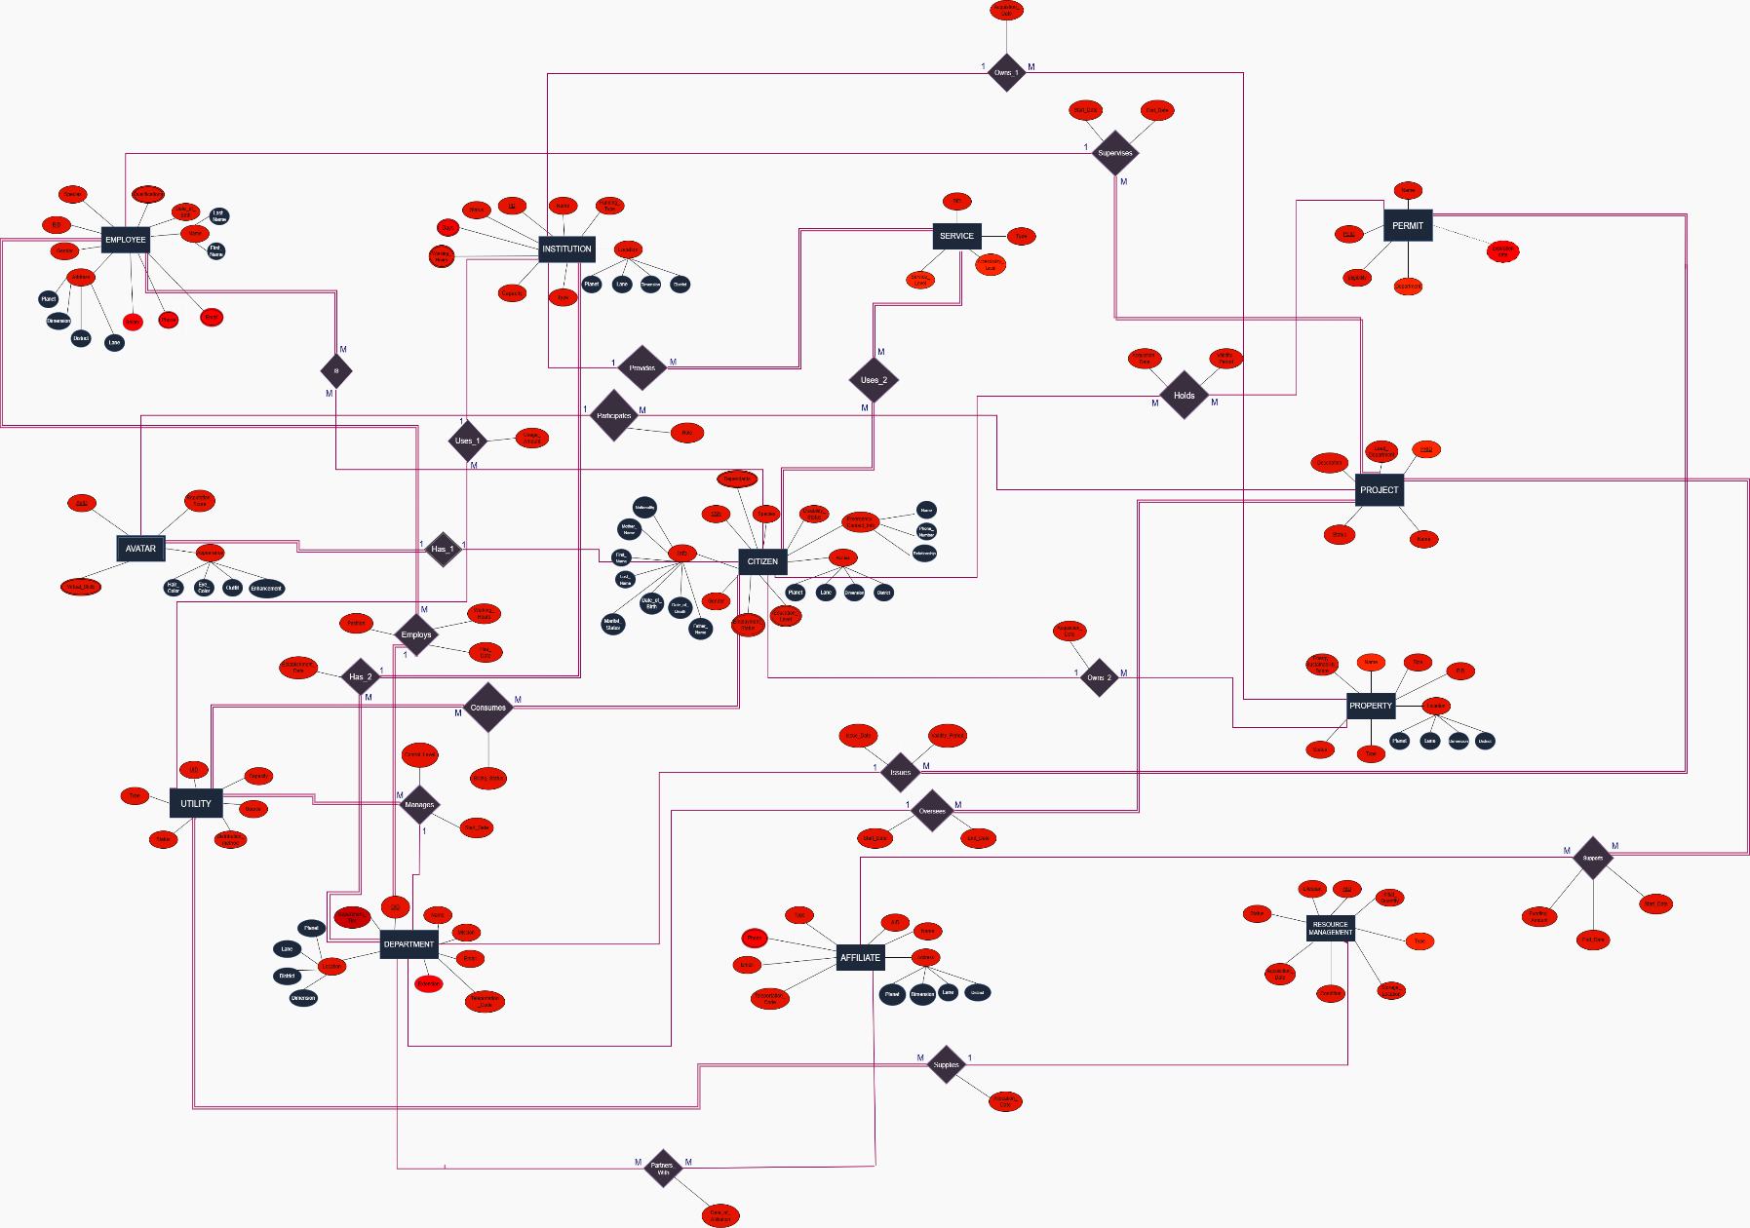
- ER Diagram for Neoterra’s Municipality
- Entity Types and Relationships
In this part, we will discuss the entity types, their attributes and the relationships between them.
- CITIZEN
The Citizens entity type represents the individuals within the societal framework of the system. It captures the core demographic, social, and personal information necessary for identification, governance, and service delivery. The entity type provides a comprehensive structure for modeling the population, encompassing personal data, familial relations, and civic attributes such as employment and education. It serves as a foundational element for establishing relationships with institutions, services, and other civic entities.
- Citizen Attributes:
- Species: A simple attribute that identifies the nature of the citizen.
Value set: {human, robot, hybrid}.
- Info: A composite attribute that includes first name, last name, date of birth, date of death, mother name, father name, nationality, and marital status sub-attributes.
- CID: A simple key attribute representing the citizen’s social security number.
- Address: A composite attribute that contains sub-components for location details, including planet, dimension, district, and lane.
- Gender: A simple attribute representing gender.
Value Set: {Terran, Mechanian, Polymorph}
- Polymorph: A dynamic, ever-changing gender that evolves across time, space, or dimension. Polymorphs are celebrated for embodying transformation and adaptability.
- Terran: A grounded gender tied to nature, stability, and creation. Terrans value harmony with their environment and community above all else.
- Mechanian: A cybernetic or synthetic gender blending human identity with machine consciousness. Mechanians often express themselves through code, rhythm, and efficiency.
- Employment Status: A multi-valued attribute since a citizen can have more than one status
Example: {Student, Employed}
- Education Level: A multi-valued attribute listing all education levels reached.
Example: {Bachelor, Master}
- Disability Status: A simple attribute indicating the disability a citizen has; null if the citizen isn’t disabled.
- Emergency Contact Info: A composite attribute with name, phone, and relationship of emergency contacts. Example: Name = "Sara", Phone = "+961111222", Relationship = "sister".
- Dependents: A multi-valued attribute listing people depending on the citizen.
Example: {Child1, Child2}.
- Citizen Relationships:
- Owns_2 → Property (1: M) (partial-to-partial):
A single citizen can own multiple properties. However, not every citizen must own a property (partial), and every property may belong to a citizen or other parties, such as institutions. (partial). It has a “Aqcuistion_Date” attribute to indicate when each citizen has purchased that property.
- Uses_2 → Service (M:M) (total-to-total):
Citizens use many services (healthcare, transport, etc.), and each service is used by many citizens. Every citizen depends on services (total), and every service must serve at least one citizen (total).
- Has_1-> Avatar (1:1) (partial-to-total):
Each citizen can have at most one digital avatar (1–1). Some may not have one (partial on Citizen), but each avatar must belong to one citizen (total). It is the identifying relationship that ties the avatar weak entity to the strong entity it depends on
- Holds → Permit (M:M) (partial-to-partial):
A citizen can hold several permits (like construction or business permits), and a permit may be held by several citizens (e.g., co-owners). Some citizens don’t hold permits (partial), and each permit can be held by not only citizens but also corporations(partial). It has “Acquistion_Dtae” and “Validity-Period” attributes that indicate when the permit was held by this citizen and the validity period of this exact one. These two relationship attributes are what the permit derived attribute “Expiration_Date” is derived from.

- Consumes → Utility (M:M) (total-to-total):
All citizens consume utilities (electricity, water), and each utility serves many citizens, which makes it many-to-many cardinality. It’s total-to-partial because all citizens consume utilities but utilities may not only be used by citizens.
- Is –> Employee (M:M) (partial-to-total):
A citizen can have multiple jobs over time (or part-time roles), and a job can involve multiple citizens (collaboration). Not all citizens are employees (partial), but every employee must be a citizen (total).

- EMPLOYEE
As every organization knows, employees form the backbone of its operations and success. The “EMPLOYEE” entity type represents all individuals who contribute to the functioning of the institution. This entity ensures proper tracking of employment details, personal information, and assigned responsibilities.

- Employee Attributes:
- EID: The key attribute. Each employee is assigned a unique identification number that distinguishes them from all others within the system.
- Name: A composite attribute consisting of two components — First Name and Last Name — allowing for organized identification of every employee.
- Date of Birth: A simple attribute representing the employee’s date of birth.
Value Set: {DD/MM/YYYY}
- Qualifications: A multivalued attribute listing the employee’s skills or abilities (e.g., Programming, Maintenance, Design).
- Address: A composite attribute containing subcomponents for location details, including Planet, Dimension, District, and Lane.
- Species: A simple attribute specifying the nature of the employee.
Value Set: {Robot, Human, Hybrid}
- Gender: A simple attribute recording the employee’s gender.
- Phone: A multivalued attribute.
- Salary: A simple attribute indicating the salary of each employee in energy points.
- Email: A multivalued attribute.
Value Set: {Terran, Mechanian, Polymorph}

- Employee Relationships:
- Supervises → Project (1:M) (partial-to-total):
One employee can supervise multiple projects, but not all employees are supervisors (partial). Each project must have a supervisor (total). It has two attributes, “Start_Date” of supervision or when the employee takes on a project, and the “End_Date” of that supervision.

- DEPARTMENT
A Department is a specialized division of the utopian municipality responsible for overseeing a unique domain of interdimensional societal balance. Each department is semi-autonomous, operating through advanced AI governance systems and human-hybrid administrators to ensure sustainable growth and harmony across both physical and virtual realms.

- Department Attributes:
- DID (Department ID): It is the key attribute; each department has a unique number ID to distinguish it from the others.
- Name: a simple name attribute that clearly reflects the work of the department.
- Mission: a simple descriptive attribute that states the goal of the department
- Location: a composite attribute of 4 sub-attributes (planet, dimension, district, lane)
- Department_Tier: a simple attribute that identifies the intergalactic tier of the dept
Value Set: {Local / Interplanetary / Virtual}
- Extension: A simple attribute that gives the phone extension of the departmental office.
- Email: A simple attribute.
- Teleportation Code: A simple attribute to show a code used to travel interdimensionally to the department headquarters.

- Department Relationships
- Manages→ Utility (1: M) (partial-to-total):
After the utilities are provided by the resource management section of our municipality, certain departments “MANAGE” the distribution and handling of our resource utilities. It is a one-to-many relationship since one department can manage multiple utilities, with a partial (department) to total (utility) participation, since not all departments are responsible for managing utilities, but all utilities need to be managed. It has 2 attributes, “Control_Level” which can either be automated, AI-Driven, or manual, and the “Start_Date” that the department took over a utility.

- Oversees→ Projects (1:M) (partial-to-total):
Municipality projects are “OVERSEEn” by the departments. It is a one-to-many relationship since one department can juggle different projects at once. Contrarily, we have a partial (department) to total (project) participation, since not all departments handle projects (ex: citizen management, accounting, etc.), but all projects are inevitably led by their respective departments. It has two attributes, “Start_Date” and “End_Date”, to keep track of when each department is handling a certain project. If the end is unknown, it is set to null.

- Issues → Permits (1:M) (partial-to-total):
Municipal departments of different types have the jurisdiction to “ISSUE” permits after studying the case of the receiver. It is a one-to-many relationship since one department can issue a plethora of related permits (ex: an Urban Infrastructure Department can issue permits for renovation, land use, construction, etc.). Yet not all departments have the authority to issue permits, while all permits need to be issued, which creates a partial to total relationship. Its two attributes “Issue_Date” and “Validity_Period” have the same role as the ones for the “Holds” relationship.

- Employs → Employees (1:M) (total-to-total)
Of course, all departments depend on employees to function. Thus, every department “EMPLOYS” employees. It is a one-to-many relationship, since one department has a collection of employees. It also maintains a total-to-total participation since all departments need to hire employees, and all employees work in departments. It has 3 attributes, “Position” to indicate the job that the employee took, the “Working_Hours” for each employee, and the “Hire_Date” of that employee, ensuring we have unique values for each hired individual.

- Since departments are in institutions, an already established relationship, and institutions use utilities, it is inferred that departments use utilities.

- UTILITY
The Utility entity represents essential infrastructure services like water, electricity, or energy in Neoterra. Each utility also needs to come from a certain source and through a certain method, and must have a certain capacity representing the amount of people it can support using this utility at one time. It connects resources (like energy generators) to properties and citizens, showing flow and accessibility.

- Utility Attributes:

- UID: The primary key that is a unique incremental value given to each utility. It is simple and single-valued.
- Type: a simple attribute to show what kind of utility it is.
- Source: a simple attribute that states the place from which the utility comes.
- Capacity: simple attribute; The number of people that are supported to use the utility at one time.
- Distribution_method: simple attribute: The method through which the utility reaches the municipality
- Status: simple; The state of the utility. It will contain a value from the following valueset: {active, inactive}

- PROJECT
Our municipality cares about its citizens and its goal is to ensure they can live as comfortable a life as possible. So, it has, is, and will realize different projects in order to make that goal a reality. We will keep track of the start and end dates, the status of the project, and allow the option to record any additional descriptions that capture essential data relating to a certain project. Different departments will manage different projects so the type of the project can be inferred from its leading department.

  - Project Attributes:
- PRID: The primary key , as it is a unique incremental value for each project.
- Name: a simple attribute to indicate the project name
- Status: Shows the state of a certain project. It is a simple attribute that will contain a value from the following value set: {finished, interrupted, uninitiated, in progress}
- Description: a simple descriptive attribute to store information about the project goals, milestones achieved, explanations for any interruptions (if any).
- Lead_Department: The department under which the project falls. It is a simple, single-valued attribute that will contain one of the department names from the department entity.

- PERMIT
The Permit entity manages legal authorization and compliance. Our municipality has a list of permits that it can grant to anyone or any institutional body that meets the eligibility conditions of a certain permit. With these permits, the permit holders will receive support from the law to do/practice something they were restricted before for a certain period of time specified by the different departments of the municipality. Each permit is issued by a department, granted to citizens or affiliates, and linked to projects to ensure legality and governance.
- Permit Attributes:
- PEID: The primary key (simple, single-valued), as it will be a unique incremental value for each permit.
2- Name: The permit name (simple, single-valued) that explains what a certain permit is for.
3- Department: The department under which the permit falls. It is a simple, single-valued attribute that will contain one of the department names from the department entity.
4- Eligibility: a simple attribute that states whether the applicant for the permit is eligible for it.
5- Expiration_Date: A derived attribute from the relationship attributes of both the “Holds” relationship and the “Issues” relationship.

- PROPERTY
Properties are essential physical assets belonging to the organization. They represent all real estate holdings used for operations, housing, or public service. The “PROPERTY” entity manages every building or land asset, tracking their usage, condition, and purpose.
- Property Attributes:
- PID: The key attribute uniquely identifying each property in the system.
- Type: A simple attribute describing the kind of property.
Value Set: {Residential, Commercial, Industrial, Agricultural, Public, Other}
- Location: A composite attribute providing full location details, composed of Planet, Dimension, District, and Lane.
- Energy Sustainability Score: A simple numeric attribute of range 0-100 indicating the property’s environmental sustainability rating or energy efficiency.
- Size: A simple attribute representing the total area of the property (in square meters or acres).
- Name: A simple attribute representing the designated name of the property or facility.
- Status: A simple attribute showing the property’s current operational state.
Value Set: {For Sale, For Rent, Sold, Rented, Under Construction}

- RESOURCE MANAGEMENT

The Resource Management entity represents the collection, distribution, and monitoring of Neoterra’s tangible and intangible assets. It does not refer to a department. These resources include physical materials, energy units, digital data streams, and other assets necessary for sustaining infrastructure, services, and utilities. This is a strong entity that functions independently while connecting with departments and projects. This entity supplies the utilities that the department manages.
    - Resource Management Attributes:
- RID: The simple key attribute that uniquely identifies each managed resource.
- Type: A simple attribute describing what kind of resource is being handled.
- Initial_Quantity: A simple attribute representing how much of the resource is initially obtained.
- Condition: A simple attribute describing the resource’s physical or operational state.
Value Set: {New, Good, Used, Damaged, Under Repair}
- Status: A simple attribute representing the operational status of the resource.
Value Set: {Available, In Use, Under Maintenance, Depleted}
- Storage_Location: a simple attribute to indicate the location or digital repository where the resource is stored or accessed.
- Lifespan: A simple attribute indicating the estimated or actual lifespan or duration of use of the resource.
- Resource Management Relationships:
- Supplies → Utilities (1:M) (partial-to-total)
A single resource can supply multiple utilities within the organization’s infrastructure and for other users. Additionally, not all resources supply utilities, but all utilities are certainly supplied by natural resources, which makes it a partial-to-total relationship. It has an attribute “Allocation_Date” indicating when the transfer of the utility was made.
- SERVICE
Defines the different offerings available to citizens, departments, and partner organizations. Each service has a type such as healthcare, education, sanitation, transport, or digital administration, and an accessibility level that sets who can use it, whether public, restricted, or internal. Services are grouped by level: basic, premium, and civic priority. This entity connects citizens and departments across the city’s digital system, promoting efficiency and accessibility. It is a strong entity that can exist independently while linking with departments and projects.

    - Service Attributes:
- SID: A simple key attribute which acts as a unique identifier that distinguishes each service entry within the system.
- Type: A simple attribute that specifies the classification or category of the service being provided.
- Accessibility Level: A simple attribute that defines who can access the service, ranging from open to the public to limited internal use. Value Set: {Public, Restricted, Internal}
- Service Level: A simple attribute that indicates the quality or priority tier assigned to the service, reflecting its importance or scope. Value Set: {Basic, Premium, Civic Priority}
- AFFILIATE
The Affiliate entity represents external organizations that maintain formal or functional relationships with the governing system. These may include companies, non-governmental organizations, or other governmental agencies that collaborate, contribute resources, or operate in partnership with internal departments and institutions. Each affiliate is uniquely identifiable within the database, allowing for structured management of organizational data, contact details, and operational timelines in a consistent and reliable manner.

- Affiliate Attributes:
- AID: A simple key attribute that uniquely identifies each affiliate.
- Name: A simple attribute that shows the affiliate’s name. Example: GreenTech Corp.
- Type: A simple attribute indicating the category of the affiliate, like company, NGO, or government agency.
- Address: A composite attribute that contains sub-components for location details, including planet, dimension, district, and lane.
- Email: A simple attribute.
- Phone: A multivalued attribute of the affiliate’s phone number.
- Teleportation_Code: A simple attribute.

- Affiliate Relationships:
- Partners with → Department (M:M) (partial-to-partial)
An affiliate (organization) can partner with several departments, and a department can partner with many affiliates. But not all affiliates partner with a department, and not all departments have partners, thus both are partial. It has one attribute “Date_of_Affiliation” to indicate when the partnership was etstablished.

- Supports → Project (M:M) (partial-to-total)
Affiliates can support many projects, and each project can have multiple affiliates. Not all affiliates must support a project (partial), but every project must have at least one supporting affiliate (total). It has 3 attributes, “Start_Date” and “End_Date” to show the period of affiliation, and the ‘Funding_Amount” given to each project by the affiliates. End_Date is set to null if unknown.

- INSTITUTION
The Institutions entity represents formal establishments responsible for providing essential public, educational, cultural, or administrative services. It encompasses a wide range of organizational types, including hospitals, schools, libraries, and governmental buildings, each functioning as a central node in societal operations. The entity supports detailed structural and operational data, enabling efficient management of institutional capacity, location, and activity status within the system’s overall governance model.

A) Institution Attributes:
- IID: A simple key attribute that uniquely identifies the institution.
  - Name: A simple attribute showing the institution’s name. Example: National Museum.
  - Type: A simple attribute indicating what kind of institution it is. Example: school.
  - Location: A composite attribute including the planet, lane, dimension, and district sub-attributes.
  - Capacity: A simple attribute representing the number of people it can hold.
  - Working_Hours: A multivalued attribute.
  - Working_days: A multivalued attribute.
  - Status: A simple attribute showing whether the institution is active, inactive, or under construction. Value set: {active, inactive, under construction, renovated}.
  - Funding Type: A simple attribute showing whether it’s publicly or privately funded. Value set: {private, public}.
B) Institution Relationships:
- Provides → Service (1:M) (partial-to-total)
The institution offers many services. It might not provide all possible services (partial), but each service must come from the institution (total).

- Uses_1→ Utility (1:M) (partial-to-partial)
One institution itself uses various utilities (electricity, systems), which makes it a one-to-many relationship. Additionally, not all institutions use all the utilities provided, and utilities are not only used by institutions. It has an attribute “Usage_Amount” to indicate the amount given to that institution of said utility.

- Has_2 → Department (1:M) (total-to-total)
One institution has multiple departments, and each department is linked to an institution (possibly multiple in a network). Both exist fully through this relationship. It has an attribute “Establishment_Date” to indicate when the department was founded in the institution.
- Owns_1 → Property (1:M) (partial-to-partial)
One institution can own multiple properties (buildings, land). It’s partial for the institution, as it may lease some instead, and it is partial for properties, since they can be owned by other parties. It has an attribute “Acquisition_Date” to indicate when the property was purchased by the institution.

12. AVATAR
A citizen’s customizable persona to represent themselves in virtual and online spaces. They can switch into this body and participate in social hubs with other avatars, as well as deal with, sign up for, and access digital municipal services. This is a weak entity that depends on the citizen strong entity for its existence.
    - Avatar Attributes:
- AVID (Avatar ID): a partial key that assigns a unique ID for the avatar, unique only for its citizen.
- Appearance: a composite attribute with 4 sub-attributes (hair_color, eye_color, enhancements, outfit)
- Virtual_skills: a multivalued attribute that reflects the special skills of an avatar (ex: programming, piloting, etc.)
- Reputation_score: a simple attribute that is assigned to the avatar from its interaction with other avatars
    - Avatar Relationships:
- Participates→ Projects (1:M) (partial-to-partial)
Since avatars have the ability to digitally interact with municipal activities, citizens can use their avatars to “PARTICIPATE” in municipal projects through volunteering, and employees may choose to do certain jobs using their avatars. It is a one-to-many relationship since one “avatar” can participate in multiple projects. Additionally, it is an optional decision, so not all “avatars” have to participate in projects, and not all projects need avatars to be done. It has a “Role” attribute to indicate whether the avatar participates as a participant, observer, or tester in the project.

- ER to Relational Mapping Algorithm
      - Step 1: Mapping of Strong Entities
In this step, we are going to convert every strong entity into a table known as a relationship table.
In this table, we will include all attributes (Except for multivalued ones). As for composite attributes, we
are going to put their simple attributes.
Our strong entities are: CITIZEN, EMPLOYEE, DEPARTMENT, UTILITY, PROJECT, PERMIT, PROPERTY, RESOURCE MANAGEMENT, SERVICE, AFFILIATE, INSTITUTION.
CITIZEN:
CID | Species | First_Name | Last_Name | Date_of_Birth | Date_of_Death | Mother_Name
Father_Name | Nationality | Marital_Status | Planet | Dimension | District | Lane
Gender | Disability_Status | EC_Name | Phone_  Number | Relationship

The CITIZEN entity has four multivalued attributes (Employment_Status, Education_Level, and Dependents) which are not represented in this table. As for the other attributes, they are all simple and all are present on the table including the primary key CID.

EMPLOYEE:
EID | First_Name | Last_Name | Date_of_Birth |  | Gender | Planet | Dimension
District | Lane | Species | Salary

The EMPLOYEE entity has several multivalued attributes (Qualifications, Email, Phone) which are not represented in this table. As for the other attributes, they are all simple and all are present on the table, including the primary key EID.

DEPARTMENT:
DID | Name | Mission | EID(foreign key) |  |  | Planet | Dimension
District | Lane | Department_Tier |  | Email | Extension |  |  | Teleportation_Code

The DEPARTMENT entity has no multivalued attribute. As for the other attributes, they are all simple and all are present on the table, including the primary key DID.

UTILITY:
UID | Type | Source | Capacity | Distribution_method | Status

The UTILITY entity has no multivalued attributes. As for the other attributes, they are all simple and all are present on the table including the primary key UID.

PROJECT:
PRID | Name | Status | Description | Lead_Department | AVID

The PROJECT entity has no multivalued attributes. As for the other attributes, they are all simple and all are present on the table including the primary key PRID.

AVATAR:
CID | AVID | Hair_Color | Eye_Color | Outfit | Enhancement | Reputation_Score

PERMIT:
PEID | Name | Expiration_Date | Department | Eligibility

The PERMIT entity has a derived attribute (Expiration_date) from the simple attributes Start_date and Length in Period. As for the other attributes, they are all simple and all are present in the table including the primary key PEID.

PROPERTY:
PID | Type | Planet |  | Dimension | District | Lane | Energy_Sustainability_Score
Size | Name | Status
All attributes of the PROPERTY entity are simple and all are present on the table including the primary key PID.

RESOURCE MANAGEMENT:
RID | Type | Initial_Quantity | Condition | Acquisition_Date | Status | Storage_Location
Lifespan
All attributes of the RESOURCE MANAGEMENT entity are simple and all are present on the table including the primary key RID.

SERVICE:
SID | Type | Accessibility_Level | Service Level

All attributes of the SERVICE entity are simple and are present on the table including the prim. key SID.

AFFILIATE:
AID | Name | Type | Planet | Dimension | District | Lane
Teleportation_Code | Email

The AFFILIATE entity has a multivalued attribute (Phone) which is not represented in this table. As for the other attributes, they are all simple and all are present on the table including the primary key AID.

INSTITUTION:
IID | Name | Type |  | Planet | Lane | Dimension | District
Capacity | Funding_Type | Status

The INSTITUTION entity has a multivalued attribute (Days, Working_Hours) which is not represented in this table. As for the other attributes, they are all simple and all are present on the table, including the primary key IID.
      - Step 2: Mapping of Weak Entities
This step is identical to step 1 for weak entities, but with only one small twist. Each weak entity
table will contain a foreign key which is the primary key of the strong entity it belongs to. The
combination of both the foreign key and the partial key sum up to have our primary key for a weak
entity.

AVATAR:
CID | AVID | Hair_Color | Eye_Color | Outfit | Enhancement | Reputation_Score

There is one multivalued attribute (Virtual Skills) that is not represented in the table. The weak entity also contains simple attributes but no primary key. The dominant entity’s key is placed as a foreign key and combined with the weak entity’s partial key to form a composite primary key. Our weak entity “AVATAR” is associated with the “CITIZEN” entity, which is the dominant one. Therefore, CID serves as the foreign key, and the combination of CID and AVID forms the primary key for the weak entity.

Avatar:
CID | AVID | Hair_Color | Eye_Color | Outfit | Enhancement | Reputation_Score
Citizen:
CID | Species | First_Name | Last_Name | Date_of_Birth | Date_of_Death | Mother_Name
Father_Name | Nationality | Marital_Status | Planet | Dimension | District | Lane
Gender | Disability_Status | Name | Phone_  Number | Relationship

      - Step 3: Mapping Binary 1:1 Relationships
In this step, we will use one of the three following approaches in order to map all 1:1 relations:
- Foreign Key approach: where we take the primary key of one of the 2 entity types, more preferably of total participation, and add it as a foreign key in the other entity type.
- Merge Relation: where we merge the two entity types into a single relation, and it is more appropriate when both participations are total.
- Cross-Reference or Relationship Relation: where we set up a new relation with cross-referencing both the entity types’ primary keys together.
As we have no 1-1 relationship between strong entity types, we will be skipping this step.

      - Step 4: Mapping Binary 1:N Relationships
In order to map 1:N relationships, we need to take all relationship attributes, the attributes of the N side, in addition to adding the primary key of the 1 side as a foreign key.
- Supplies:
UID | Capacity | Source | Distribution_Method | Status | Type | Allocation_Date | RID
Resource_Management (1 side) supplies Utility (N side), so RID, the primary key of Resource_Management, is a foreign key in this mapping in addition to the Utility attributes and the relationship attributes (Allocation_Date).
- Owns_2:
PID | Type | Planet | Lane | Dimension | District | Energy_Sustainability_Score
Size | Name | Acquisition_Date | Status | CID
Citizen (1 side) owns Property (N side), so CID, the primary key of citizen, is a foreign key in this mapping in addition to the property attributes and the relationship attributes (Acquisition_Date).
- Supervises:
PRID | Name | Description | Start_Date | End_Date | Lead_Department | Status | EID
Employee (1 side) supervises Project (N side), so EID, the primary key of employee, is a foreign key in this mapping in addition to the project attributes and the relationship attributes (Start_Date, End_Date).

- Manages:
UID | Type | Source | Capacity | Distribution_Method | Status | Control_Level | Start_Date | DID
Department (1 side) manages Utility (N side), so DID, the primary key of Department, is a foreign key in this mapping in addition to the Utility attributes and the relationship attributes (Control_Level, Start_Date).
- Oversees:
PRID | Name | Description | Start_Date | End_Date | Lead_Department | Status | DID
Department (1 side) oversees Project (N side), so DID, the primary key of Department, is a foreign key in this mapping in addition to the Project attributes and the relationship attributes (Start_Date, End_Date)
- Issues:
PEID | Name | Eligibility | Issue_Date | Validity_Period | Expiration_Date | Department | DID
Department (1 side) issues Permit (N side), so DID, the primary key of Department, is a foreign key in this mapping in addition to the Permit attributes and the relationship attributes (Issue_Date, Validity_Period)
- Employs:
EID | Species |  | Gender |  | First_Name |  | Last_Name |  | DOB |  | Hire_Date | Planet
Dimension |  | District |  | Lane |  | Working_Hours |  | Salary |  | Position |  |  | DID
Department (1 side) Employs Employee (N side), so DID, the primary key of Department, is a foreign key in this mapping in addition to the Employee attributes and the relationship attributes (Position, Hire_Date, Working_Hours)
- Provides:
SID | Type | Accessibility_Level | Service_Level | IID
Institution (1 side) Provides Service (N side), so IID, the primary key of Institution, is a foreign key in this mapping in addition to the Service attributes.
- Uses_1:
UID | Type | Source | Capacity | Distribution_Method | Status | Usage_Amount | IID
Institution (1 side) Uses Utility (N side), so IID, the primary key of Institution, is a foreign key in this mapping in addition to the Utility attributes and the relationship attributes (Usage_Amount)
- Has_2:
DID | Name | Mission | Email | Extension | Teleportation_Code |  | Establishment_Date
EID | Name | Planet | Lane | District | Dimension | Department_Tier |  | IID
Institution (1 side) Has Department (N side), so IID, the primary key of Institution, is a foreign key in this mapping in addition to the Department attributes and the relationship attributes (Establishment_Date)
- Owns_1:
PID | Type | Planet | Lane | Dimension | District | Energy_Sustainability_Score
Size | Name | Acquisition_Date | Status | IID
Institution (1 side) Owns Property (N side), so IID, the primary key of Institution, is a foreign key in this mapping in addition to the Property attributes and the relationship attributes (Acquisition_Date).
NOTE: At the end of the mappings segments is a relational mapped schema of the previous, showing the connections of the foreign keys

      - Step 5: Mapping of Binary M:N Relationship Types
To map the M:N relationships, we are required to include all simple attributes of the relationship, including the primary keys of both entities, and the relational mapping of foreign keys.
CITIZEN:
CID | Species | First_Name | Last_Name | Date_of_Birth | Date_of_Death | Mother_Name
Father_Name | Nationality | Marital_Status | Planet | Dimension | District | Lane
Gender | Disability_Status | Name | Phone_Number | Relationship

SERVICE:
SID | Type | Accessibility_Level | Service Level

USES_2:
CID | SID
The link between “CITIZEN” and “SERVICE” includes their primary keys CID and SID.
EMPLOYEE:
EID | First_Name | Last_Name | Date_of_Birth | Gender | Planet | Dimension
District | Lane | Species | Hire_Date | Position | Working_Hours | Salary

IS:
EID | CID

The link between “EMPLOYEE” and “CITIZEN” includes their primary keys EID and CID.

UTILITY:
UID | Type | Source | Capacity | Distribution_method | Status

CITIZEN:
CID | Species | First_Name | Last_Name | Date_of_Birth | Date_of_Death | Mother_Name
Father_Name | Nationality | Marital_Status | Planet | Dimension | District | Lane
Gender | Disability_Status | Name | Phone_Number | Relationship

CONSUMES:
CID | UID | Billing_Status

The link between “CITIZEN” and “UTILITY” includes their primary keys CID and UID.
It also includes the relational attribute BILLING STATUS.

DEPARTMENT:
DID | Name | Mission | Name |  |  | EID |  | Planet | Dimension
District | Lane | Department_Tier |  | Email | Extension |  | Teleportation_Code

AFFILIATE:
AID | Name | Type | Planet | Dimension | District | Lane
Teleportation_Code | Email

PARTNERS_WITH:
DID | AID | Date_of_Affiliation
The link between “DEPARTMENT” and “AFFILIATE” includes their primary keys DID and AID.
It also includes the relational attribute Date_of_Affiliation.
PERMIT:
PEID | Name | Expiration_Date | Department | Eligibility

CITIZEN:
CID | Species | First_Name | Last_Name | Date_of_Birth | Date_of_Death | Mother_Name
Father_Name | Nationality | Marital_Status | Planet | Dimension | District | Lane
Gender | Disability_Status | Name | Phone_Number | Relationship

HOLDS:
CID | PEID | Aqcuistion_Date | Validity_Period

The link between “CITIZEN” and “PERMITS” includes their primary keys CID and PEID.
It also includes the relational attributes Acquisition_Date and Validity_Period.
PROJECT:
PRID | Name | Start | End | Status | Description | Lead_Department

AFFILIATE:
AID | Name | Type | Planet | Dimension | District | Lane
Teleportation_Code | Email

SUPPORTS:
AID | PRID | Funding_Amount | Start_Date | End_Date

The link between “AFFILIATE” and “PROJECT” includes their primary keys AID and PRID.
It also includes the relational attribute Funding_Amount, Start_Date, and End_Date.

      - Step 6: Mapping of multivalued attributes
In this step, multivalued attributes will be represented with the primary key of the strong entity it is present in. We have 8 multivalued attributes along the entity types.
The alliance of the primary key and that attribute combined create the relation.
EMPLOYMENT STATUS:
Employment Status | CID
The “EMPLOYMENT STATUS” relation holds the primary key CID of the strong entity “CITIZEN”.
EDUCATION LEVEL:
Education Level | CID
The “EDUCATION LEVEL” relation holds the primary key CID of the strong entity “CITIZEN”. The primary key is formed of both Education Level and CID.
DEPENDENTS:
Dependents | CID
The “DEPENDENTS” relation holds the primary key CID of the strong entity “CITIZEN”. The primary key is formed of both Dependents and CID.
QUALIFICATIONS:
Qualifications | EID
The “QUALIFICATIONS” relation holds the primary key EID of the strong entity “EMPLOYEE”. The primary key is formed of both Qualifications and EID.

E_PHONE:
Phone | EID
The “E_PHONE” relation holds the primary key EID of the strong entity “EMPLOYEE”. The primary key is formed of both Phone and EID.
EMAIL:
Email | EID
The “EMAIL” relation holds the primary key EID of the strong entity “EMPLOYEE”. The primary key is formed of both Email and EID.
A_PHONE:
Phone | AID
The “A_PHONE” relation holds the primary key AID of the strong entity “AFFLIATE”. The primary key is formed of both Phone and AID.
Virtual_Skills:
CID | AVID
The “VIRTUAL_SKILLS” relation holds the primary key AVID of the weak entity “AVATAR”. The primary key is formed of both Virtual_SKILLS and AVID.
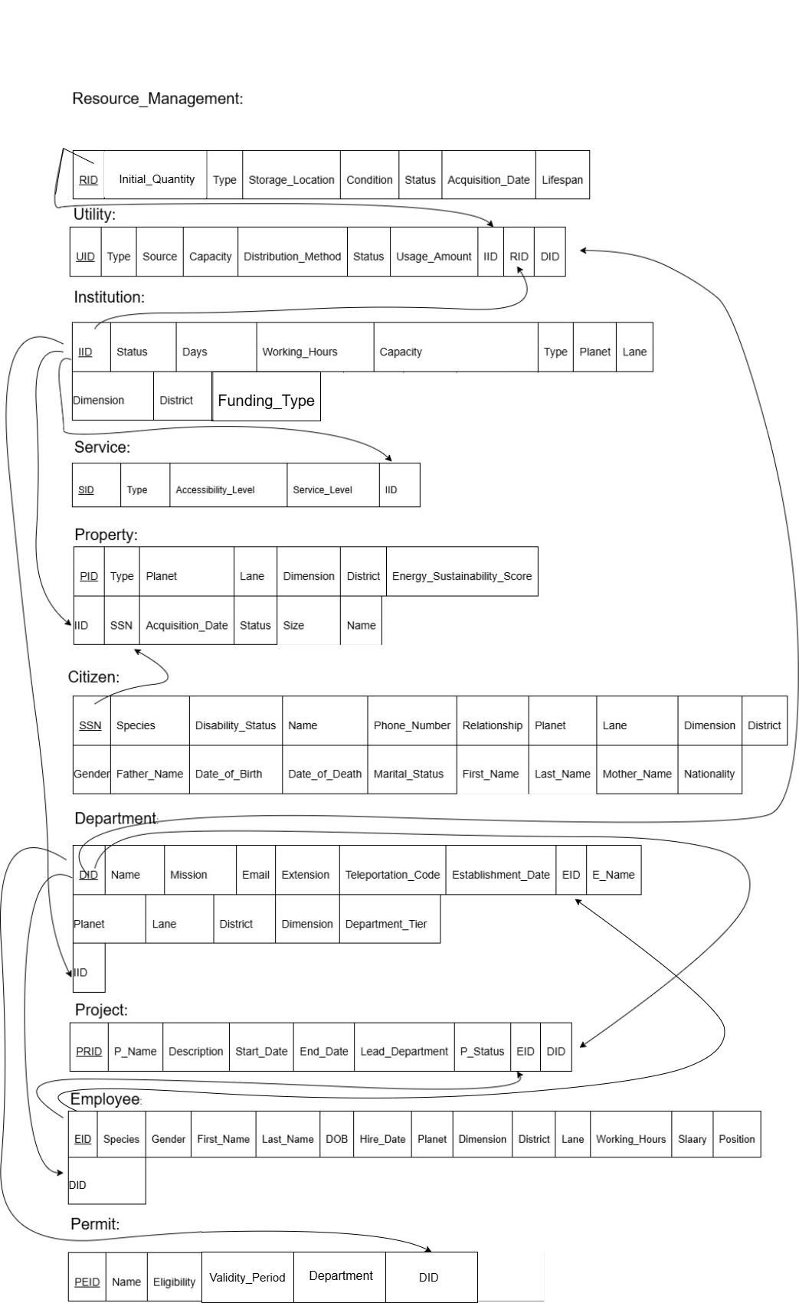
Expiration_Date
- Normalization
In this step, we will discuss the normalization status of our entities and relations.
For all the following strong entities:
- 1NF is satisfied since all the values are atomic; we have excluded multivalued attributes, and all composite attributes are broken down.
- 2NF is satisfied since each entity has a single-attribute primary key, thus we have no partial dependencies because all attributes are functionally dependent on the primary key.
- 3NF is also satisfied (except for the department entity, which is fixed) since there are no transitive dependencies among non-key attributes; all only depend on the primary key.
- Each entity has a single-attribute primary key (CID, EID, DID, etc.), which is also the only candidate key of its relation. Every non-prime attribute is fully functionally dependent on this primary key, so no non-prime attribute functionally determines any other attribute. Therefore, all strong entity relations in the Neoterra database design are in BCNF, as every determinant is a key and no partial or transitive dependencies exist.

CITIZEN:
CID | Species | First_Name | Last_Name | Date_of_Birth | Date_of_Death | Mother_Name
Father_Name | Nationality | Marital_Status | Planet | Dimension | District | Lane
Gender | Disability_Status | EC_Name | Phone_  Number | Relationship
FD1

EMPLOYEE:

EID | First_Name | Last_Name | Date_of_Birth |  | Gender | Planet | Dimension
District | Lane | Species | Salary
FD1

DEPARTMENT(before fix):
FD2

DID | Name | Mission |  | Name (for head of department) |  |  | EID | Planet |  | Dimension
District | Lane | Department_Tier | Email |  | Extension | Teleportation_Code
FD1
To avoid transitive dependencies since the name of the head of the department depends on the EID (DID → Head_EID, Head_EID → Head_Name), which is not a primary key here, and logic errors, the composite attribute Head_of_Department with sub-attributes name of employee and EID is removed and replaced by a foreign key EID to establish a link between the two entity types; a more efficient solution than dividing it into smaller tables.

DEPARTMENT(after fix):

DID | Name | Mission |  | EID (foreign key) |  | Planet |  | Dimension
District | Lane | Department_Tier | Email |  | Extension |  | Teleportation_Code
FD1

UTILITY:
UID | Type | Source | Capacity | Distribution_method | Status
FD1

PROJECT:
PRID | Name | Status | Description | Lead_Department
FD1

PERMIT:
PEID | Name | Eligibility | Expiration_Date | DID (foreign key) | Department
FD1
(note that department isn’t a foreign key but a simple attribute that states the name of the dept that first issued the permit)
PROPERTY:
PID | Type | Planet |  | Dimension | District | Lane | Energy_Sustainability_Score
Size | Name | Status
FD1

RESOURCE MANAGEMENT:
RID | Type | Initial_Quantity | Condition | Acquisition_Date | Status | Storage_Location
Lifespan
FD1

SERVICE:
SID | Type | Accessibility_Level | Service Level
FD1

AFFILIATE:
AID | Name | Type | Planet | Dimension | District | Lane
Teleportation_Code | Email
FD1

INSTITUTION:
IID | Name | Type |  | Planet | Lane | Dimension | District
Capacity | Funding_Type | Status
FD1

AVATAR:
CID | AVID | Hair_Color | Eye_Color | Outfit | Enhancement | Reputation_Score
FD2

The Avatar entity is normalized up to Third Normal Form (3NF).
Since it is a weak entity, it depends on its identifying strong entity Citizen for its existence.
Its composite primary key (CID, AVID) uniquely identifies each avatar associated with a specific citizen. Every non-key attribute depends on the whole composite key, and not on a part of it, therefore, there are no partial dependencies. If one of the keys is dropped, the FD does not hold, satisfying 2NF.
There are also no transitive dependencies, since each attribute directly describes the avatar itself, not another non-key attribute, satisfying 3NF. The foreign key CID simply ensures referential integrity with the Citizen entity without violating normalization rules.

Resource_Management supplies Utility
UID | Capacity | Source | Distribution_Method | Status | Type | Allocation_Date | RID
FD1
- 1NF: satisfied, since all attributes are atomic.
- 2NF: satisfied, since every non-key attribute depends fully on UID; no partial dependencies exist.
- 3NF: satisfied, since there are no transitive dependencies since RID (FK) only references Resource_Management without determining other attributes.
- BCNF: satisfied, since UID is the only determinant; all dependencies are on candidate keys, and the FK (RID) maintains referential integrity.

Citizen owns_2 Property
FD1
PID | Type | Planet | Lane | Dimension | District | Energy_Sustainability_Score
Size | Name | Acquisition_Date | Status | CID

- 1NF: satisfied, since all attributes are atomic.
- 2NF: satisfied, since all attributes depend entirely on PID, which is the primary key.
- 3NF: satisfied, since no transitive dependency since Citizen data is accessed only through CID (FK).
- BCNF: satisfied, since PID uniquely determines all attributes, with CID acting solely as a foreign key.

Employee supervises Project
PRID | Name  FD1 | Description | Start_Date | End_Date | Lead_Department | Status | EID

- 1NF: satisfied, since all attributes are atomic.
- 2NF: satisfied, since all non-key attributes depend fully on PRID.
- 3NF: satisfied, since there are no transitive dependencies; EID (FK) references Employee without determining project attributes.
- BCNF: satisfied, since PRID is the only determinant; EID functions as a non-determinant FK preserving dependency rules.

Department manages Utility
FD1
UID | Type | Source | Capacity | Distribution_Method | Status | Control_Level
Start_Date | DID

- 1NF: satisfied, since all attributes are atomic.
- 2NF: satisfied, since every attribute depends fully on UID.
- 3NF: satisfied, since no transitive dependency exists; DID (FK) links to Department without redundancy.
- BCNF: satisfied, since UID is the determinant; DID (FK) doesn’t introduce any dependency violations.
Department oversees Project
PRID | Name | Description | Start_Date | End_Date | Lead_Department | Status | DID
FD1
- 1NF: satisfied, since All attributes are atomic.
- 2NF: satisfied, since All non-key attributes depend fully on PRID.
- 3NF: satisfied, since No transitive dependencies exist; DID (FK) references Department only (End_Date does not depend on Start_Date, it is set to null until manually changed since projects might have an indefinite execution period).
- BCNF: satisfied, since PRID uniquely determines all project details; DID is a non-determinant FK.

Department issues Permit
PEID | Name | Eligibility | Validity_Period | Department | DID
FD1
- 1NF: satisfied, since All attributes are atomic.
- 2NF: satisfied, since All attributes depend fully on PEID.
- 3NF: satisfied, since No transitive dependencies since Department details are referenced by DID.
- BCNF: satisfied, since PEID is the only determinant; all FKs serve referential roles only.

Department employs Employee
FD1
EID | Species |  | Gender |  | First_Name |  | Last_Name |  | DOB |  | Hire_Date | Planet
Dimension |  | District |  | Lane |  | Working_Hours |  | Salary |  | Position |  |  | DID

- 1NF: satisfied, since All attributes are atomic.
- 2NF: satisfied, since All employee details depend fully on EID.
- 3NF: satisfied, since No transitive dependencies remain; Department details accessed through DID only.
- BCNF: satisfied, since EID determines all attributes; DID is a non-determinant FK maintaining referential integrity.

Institution provides Service
SID | Type  FD1 | Accessibility_Level | Service_Level | IID

- 1NF: satisfied, since all attributes are atomic.
- 2NF: satisfied, since every attribute depends fully on SID.
- 3NF: satisfied, since no transitive dependency; Institution information linked only through IID.
- BCNF: satisfied, since SID is the determinant; IID is a valid FK preserving BCNF compliance.

Institution uses_1 Utility
UID | Type | Source | Capacity  FD1 | Distribution_Method | Status | Usage_Amount | IID

- 1NF: satisfied, since all attributes are atomic.
- 2NF: satisfied, since all attributes depend entirely on UID.
- 3NF: satisfied, since no transitive dependency; IID (FK) connects Institution without redundancy.
- BCNF: UID is the only determinant; IID (FK) does not violate BCNF.

Institution has_2 Department

DID | Name |  | Mission |  | Email | Extension |  | Teleportation_Code |  | Establishment_Date
EID | Planet | Lane |  | District |  |  | Dimension |  | Department_Tier |  | IID
FD1
- 1NF: satisfied, since all attributes are atomic.
- 2NF: satisfied, since all attributes depend fully on DID.
- 3NF: satisfied, since no transitive dependency; EID is now a foreign key referencing Employee, and IID connects Institution without redundancy.
- BCNF: satisfied, since DID is the determinant; both EID and IID are foreign keys that preserve dependency integrity.

Institution owns_1 Property

PID | Type | Planet | Lane | Dimension | District | Energy_Sustainability_Score
Size | Name  FD1 | Acquisition_Date | Status | IID

- 1NF: satisfied, since all attributes are atomic.
- 2NF: satisfied, since all attributes depend entirely on PID.
- 3NF: satisfied, since no transitive dependency since Institution data is accessed via IID (FK).
- BCNF: satisfied, since PID is the determinant; IID is a foreign key ensuring referential consistency.

USES_2:
CID | SID
Does not have non-prime attributes.
IS:
EID | CID
Does not have non-prime attributes.
CONSUMES:
CID | UID | Billing_Status
FD1
The CONSUMES relation schema satisfies all conditions of the 1NF because it has neither multivalued attributes nor composite attributes. All attributes are single and atomic.
The CONSUMES relation schema satisfies all conditions of the 2NF because the non-prime attribute (Billing_Status) is fully functionally dependent on the composite primary key (CID, UID) and if one were dropped it would not hold.
The CONSUMES relation schema also satisfies all conditions of the 3NF because it satisfies the 2NF and there are no non-prime attributes that are transitively dependent on the composite primary key (CID, UID).
The CONSUMES relation schema satisfies all conditions of the BCNF because there exists no functional dependency X → A where X is not a super key or A is a prime attribute and X is not a super key.

PARTNERS_WITH:
DID | AID | Date_of_Affiliation
FD1
The PARTNERS_WITH relation schema satisfies all conditions of the 1NF because it has neither multivalued attributes nor composite attributes. All attributes are single and atomic.
It also satisfies all conditions of the 2NF because the non-prime attribute (Date_of_Affiliation) is fully functionally dependent on the composite primary key (DID, AID) and if one were dropped it would not hold.
The PARTNERS_WITH relation schema satisfies all conditions of the 3NF because it satisfies the 2NF and there are no non-prime attributes that are transitively dependent on the composite primary key (DID, AID).
The PARTNERS_WITH relation schema satisfies all conditions of the BCNF because there exists no functional dependency X → A where X is not a super key or A is a prime attribute and X is not a super key.

HOLDS:
CID | PEID | Aqcuistion_Date | Validity_Period
FD1
The HOLDS relation schema satisfies all conditions of the 1NF because it has neither multivalued attributes nor composite attributes. All attributes are single and atomic.
It satisfies all conditions of the 2NF as well because the non-prime attributes (Acquisition_Date, Validity_Period) are fully functionally dependent on the composite primary key (CID, PEID) and if one were dropped it would not hold.
The HOLDS relation schema satisfies all conditions of the 3NF because it satisfies the 2NF and there are no non-prime attributes that are transitively dependent on the composite primary key (CID, PEID).
The HOLDS relation schema satisfies all conditions of the BCNF because there exists no functional dependency X → A where X is not a super key or A is a prime attribute and X is not a super key.

SUPPORTS:
AID | PRID | Funding_Amount | Start_Date | End_Date
FD1
The SUPPORTS relation schema satisfies all conditions of the 1NF because it has neither multivalued attributes nor composite attributes. All attributes are single and atomic.
It also satisfies all conditions of the 2NF because the non-prime attributes (Funding_Amount, Start_Date, End_Date) are fully functionally dependent on the composite primary key (AID, PRID) and if one were dropped it would not hold.
The SUPPORTS relation schema satisfies all conditions of the 3NF because it satisfies the 2NF and there are no non-prime attributes that are transitively dependent on the composite primary key (AID, PRID).
The SUPPORTS relation schema satisfies all conditions of the BCNF because there exists no functional dependency X → A where X is not a super key or A is a prime attribute and X is not a super key.

EMPLOYMENT STATUS:
Employment Status | CID
Does not have non-prime attributes.
EDUCATION LEVEL:
Education Level | CID
Does not have non-prime attributes.

DEPENDENTS:
Dependents | CID
Does not have non-prime attributes.
QUALIFICATIONS:
Qualifications | EID
Does not have non-prime attributes.
E_PHONE:
Phone | EID
Does not have non-prime attributes.
EMAIL:
Email | EID
Does not have non-prime attributes.
A_PHONE:
Phone | AID
Does not have non-prime attributes.
Virtual_Skills:
CID | AVID
Does not have non-prime attributes.

- Table Structures
In this part, we are going to translate the ER Diagram into an actual database. The database tables will be instantiated using Oracle Database Server.

CITIZEN
CREATE TABLE CITIZEN (
CID INT PRIMARY KEY,
Species VARCHAR(5) CHECK (Species IN ('human', 'hybrid', 'robot')),
First_Name VARCHAR(20) NOT NULL,
Last_Name VARCHAR(20),
Date_Of_Birth DATE,
Date_Of_Death DATE,
Mother_Name VARCHAR(20),
Father_Name VARCHAR(20),
Nationality VARCHAR(20),
Marital_Status VARCHAR(3),
Planet VARCHAR(20),
Dimension VARCHAR(20),
District VARCHAR(20),
Lane VARCHAR(20),
Gender VARCHAR(20) CHECK (Gender IN ('Terran', 'Mechanian', 'Polymorph')),
Disability_Status VARCHAR(3),
EC_Name VARCHAR(50),
Phone_Number INT,
Relationship VARCHAR(50)
);

SERVICE
CREATE TABLE SERVICE (
SID INT PRIMARY KEY,
Type VARCHAR(20),
Accessibility_Level VARCHAR(20),
Service_Level VARCHAR(20)
);

EMPLOYEE
CREATE TABLE EMPLOYEE (
EID INT PRIMARY KEY,
First_Name VARCHAR(20) NOT NULL,
Last_Name VARCHAR(20),
Date_Of_Birth DATE,
Gender VARCHAR(20),
Planet VARCHAR(20),
Dimension VARCHAR(20),
District VARCHAR(20),
Lane VARCHAR(20),
Species VARCHAR(10) CHECK (Species IN ('human', 'robot', 'hybrid')),
Salary DECIMAL(12,2)
);

RESOURCE_MANAGEMENT
CREATE TABLE RESOURCE_MANAGEMENT (
RID INT PRIMARY KEY,
Type VARCHAR(20),
Initial_Quantity INT,
Condition_Desc VARCHAR(20),
Acquisition_Date DATE,
Status VARCHAR(20),
Storage_Location VARCHAR(20),
Lifespan_Days INT
);

UTILITY
CREATE TABLE UTILITY (
UID INT PRIMARY KEY,
Type VARCHAR(20),
Source VARCHAR(20),
Capacity INT,
Distribution_Method VARCHAR(20),
Status VARCHAR(20),
Managed_By_DID INT,
Supplied_By_RID INT,

FOREIGN KEY (Managed_By_DID) REFERENCES DEPARTMENT(DID)
ON DELETE SET NULL,
FOREIGN KEY (Supplied_By_RID) REFERENCES RESOURCE_MANAGEMENT(RID)
ON DELETE SET NULL
);

DEPARTMENT
CREATE TABLE DEPARTMENT (
DID INT PRIMARY KEY,
Name VARCHAR(20) NOT NULL,
Mission VARCHAR(20),
Head_EID INT,
Planet VARCHAR(20),
Dimension VARCHAR(20),
District VARCHAR(20),
Lane VARCHAR(20),
Department_Tier VARCHAR(20) CHECK (Department_Tier IN ('Local', 'Interplanetary', 'Virtual')),
Email VARCHAR(20),
Extension VARCHAR(20),
Teleportation_Code VARCHAR(20),

FOREIGN KEY (Head_EID) REFERENCES EMPLOYEE(EID)
ON DELETE SET NULL
);

PROJECT
CREATE TABLE PROJECT (
PRID INT PRIMARY KEY,
Name VARCHAR(20) NOT NULL,
Start_Date DATE,
End_Date DATE,
Status VARCHAR(20),
Description TEXT,
Lead_Department INT NOT NULL,
CID INT,
AVID INT,

FOREIGN KEY (Lead_Department) REFERENCES DEPARTMENT(DID),
FOREIGN KEY (CID, AVID) REFERENCES AVATAR(CID, AVID)
);

PERMIT
CREATE TABLE PERMIT (
PEID INT PRIMARY KEY,
Name VARCHAR(20) NOT NULL,
Issue_Date DATE,
Validity_Period_Days INT,
Expiration_Date DATE,
Department_Issuer INT,
Eligibility VARCHAR(10),

FOREIGN KEY (Department_Issuer) REFERENCES DEPARTMENT(DID)
ON DELETE SET NULL
);

PROPERTY
CREATE TABLE PROPERTY (
PID INT PRIMARY KEY,
Type VARCHAR(20),
Planet VARCHAR(20),
Dimension VARCHAR(20),
District VARCHAR(20),
Lane VARCHAR(20),
Energy_Sustainability_Score DECIMAL(5,2)
CHECK (Energy_Sustainability_Score BETWEEN 0 AND 100),
Size DECIMAL(10,2),
Name VARCHAR(20),
Status VARCHAR(20)
);

AFFILIATE
CREATE TABLE AFFILIATE (
AID INT PRIMARY KEY,
Name VARCHAR(20) NOT NULL,
Type VARCHAR(20),
Planet VARCHAR(20),
Dimension VARCHAR(20),
District VARCHAR(20),
Lane VARCHAR(20),
Teleportation_Code VARCHAR(20),
Email VARCHAR(20)
);

INSTITUTION
CREATE TABLE INSTITUTION (
IID INT PRIMARY KEY,
Name VARCHAR(20) NOT NULL,
Type VARCHAR(20),
Planet VARCHAR(20),
Lane VARCHAR(20),
Dimension VARCHAR(20),
District VARCHAR(20),
Capacity INT,
Funding_Type VARCHAR(20),
Status VARCHAR(20)
);

Supervises
CREATE TABLE Supervises (
EID INT NOT NULL,
PRID INT NOT NULL,
Start_Date DATE,
End_Date DATE,
PRIMARY KEY (EID, PRID)
);

AVATAR
CREATE TABLE AVATAR (
CID INT,
AVID INT,
Hair_Color VARCHAR(20),
Eye_Color VARCHAR(20),
Outfit VARCHAR(20),
Enhancement VARCHAR(20),
Reputation_Score INT,

PRIMARY KEY (CID, AVID),
FOREIGN KEY (CID) REFERENCES CITIZEN(CID)
);

Supplies
CREATE TABLE Supplies (
RID INT NOT NULL,
UID INT NOT NULL,
Allocation_Date DATE,
PRIMARY KEY (RID, UID)
);

Owns_2
CREATE TABLE Owns_2 (
CID INT NOT NULL,
PID INT NOT NULL,
Acquisition_Date DATE,
PRIMARY KEY (CID, PID)
);

Manages
CREATE TABLE Manages (
DID INT NOT NULL,
UID INT NOT NULL,
Control_Level VARCHAR(50),
Start_Date DATE,
PRIMARY KEY (DID, UID));
Oversees
CREATE TABLE Oversees (
DID INT NOT NULL,
PRID INT NOT NULL,
Start_Date DATE,
End_Date DATE,
PRIMARY KEY (DID, PRID)
);

Issues
CREATE TABLE Issues (
DID INT NOT NULL,
PEID INT NOT NULL,
Issue_Date DATE,
Validity_Period INT,
PRIMARY KEY (DID, PEID)
);

Employs
CREATE TABLE Employs (
DID INT NOT NULL,
EID INT NOT NULL,
Position VARCHAR(255),
Hire_Date DATE,
Working_Hours INT,
PRIMARY KEY (DID, EID)
);
USES_2
CREATE TABLE USES_2 (
CID INT,
SID INT,

PRIMARY KEY (CID, SID),
FOREIGN KEY (CID) REFERENCES CITIZEN(CID),
FOREIGN KEY (SID) REFERENCES SERVICE(SID));
Uses_1
CREATE TABLE Uses_1 (
IID INT NOT NULL,
UID INT NOT NULL,
Usage_Amount INT,
PRIMARY KEY (IID, UID)
);

Provides
CREATE TABLE Provides (
IID INT NOT NULL,
SID INT NOT NULL,
PRIMARY KEY (IID, SID)
);

Has_2
CREATE TABLE Has_2 (
IID INT NOT NULL,
DID INT NOT NULL,
Establishment_Date DATE,
PRIMARY KEY (IID, DID)
);

CONSUMES
CREATE TABLE CONSUMES (
CID INT,
UID INT,
Billing_Status VARCHAR(30),

PRIMARY KEY (CID, UID),
FOREIGN KEY (CID) REFERENCES CITIZEN(CID),
FOREIGN KEY (UID) REFERENCES UTILITY(UID)
);

Owns_1
CREATE TABLE Owns_1 (
IID INT NOT NULL,
PID INT NOT NULL,
Acquisition_Date DATE,
PRIMARY KEY (IID, PID)
);

AVATAR
CREATE TABLE AVATAR (
CID INT,
AVID INT,
Hair_Color VARCHAR(30),
Eye_Color VARCHAR(30),
Outfit VARCHAR(50),
Enhancement VARCHAR(50),
Reputation_Score INT,

PRIMARY KEY (CID, AVID),
FOREIGN KEY (CID) REFERENCES CITIZEN(CID)
);

IS
CREATE TABLE IS (
EID INT,
CID INT,

PRIMARY KEY (EID, CID),
FOREIGN KEY (EID) REFERENCES EMPLOYEE(EID),
FOREIGN KEY (CID) REFERENCES CITIZEN(CID)
);

PARTNERS_WITH
CREATE TABLE PARTNERS_WITH (
DID INT,
AID INT,
Date_of_Affiliation DATE,

PRIMARY KEY (DID, AID),
FOREIGN KEY (DID) REFERENCES DEPARTMENT(DID),
FOREIGN KEY (AID) REFERENCES AGENCY(AID)
);

HOLDS
CREATE TABLE HOLDS (
CID INT,
PEID INT,
Acquisition_Date DATE,
Validity_Period VARCHAR(50),

PRIMARY KEY (CID, PEID),
FOREIGN KEY (CID) REFERENCES CITIZEN(CID),
FOREIGN KEY (PEID) REFERENCES PERMIT(PEID)
);

EMPLOYMENT_STATUS
CREATE TABLE Employment_Status (
CID INT NOT NULL,
Employment_Status VARCHAR(50) NOT NULL,
PRIMARY KEY (CID, Employment_Status),
FOREIGN KEY (CID) REFERENCES Citizen(CID)
);
SUPPORTS
CREATE TABLE SUPPORTS (
AID INT,
PRID INT,
Funding_Amount NUMBER,
Start_Date DATE,
End_Date DATE,

PRIMARY KEY (AID, PRID),
FOREIGN KEY (AID) REFERENCES AFFILIATE(AID),
FOREIGN KEY (PRID) REFERENCES PROJECT(PRID)
);

QUALIFICATIONS
CREATE TABLE Qualifications (
EID INT NOT NULL,
Qualification VARCHAR(100) NOT NULL,
PRIMARY KEY (EID, Qualification),
FOREIGN KEY (EID) REFERENCES Employee(EID)
);

EDUCATION_LEVEL
CREATE TABLE Education_Level (
CID INT NOT NULL,
Education_Level VARCHAR(50) NOT NULL,
PRIMARY KEY (CID, Education_Level),
FOREIGN KEY (CID) REFERENCES Citizen(CID)
);

DEPENDENTS
CREATE TABLE Dependents (
CID INT NOT NULL,
Dependent VARCHAR(100) NOT NULL,
PRIMARY KEY (CID, Dependent),
FOREIGN KEY (CID) REFERENCES Citizen(CID)
);

E_PHONE
CREATE TABLE E_Phone (
EID INT NOT NULL,
Phone INT(20) NOT NULL,
PRIMARY KEY (EID, Phone),
FOREIGN KEY (EID) REFERENCES Employee(EID)
);

E_EMAIL
CREATE TABLE E_Email (
EID INT NOT NULL,
Email VARCHAR(100) NOT NULL,
PRIMARY KEY (EID, Email),
FOREIGN KEY (EID) REFERENCES Employee(EID)
);

A_PHONE
CREATE TABLE A_Phone (
AID INT NOT NULL,
Phone INT NOT NULL,
PRIMARY KEY (AID, Phone),
FOREIGN KEY (AID) REFERENCES Affiliate(AID));
VIRTUAL_SKILLS
CREATE TABLE Virtual_Skills (
CID INT NOT NULL,
AVID INT NOT NULL,
Virtual_Skill VARCHAR(100) NOT NULL,
PRIMARY KEY (CID, AVID, Virtual_Skill),
FOREIGN KEY (CID, AVID) REFERENCES Avatar(CID, AVID)
);

VII. Table Description

CITIZEN

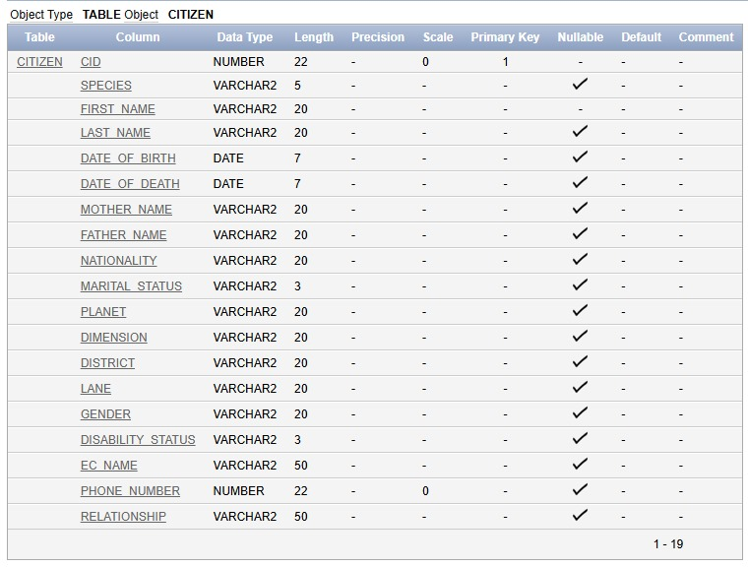

DEPARTMENT

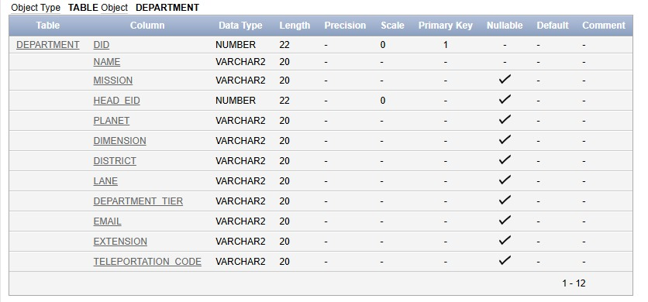

RESOURCE_MANAGEMENT
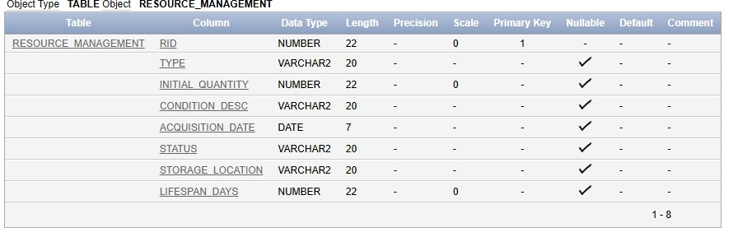

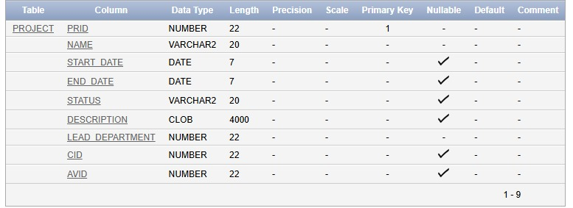
PROJECT
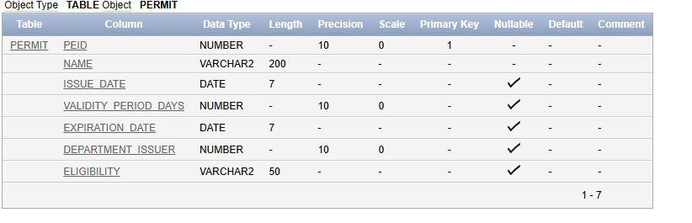
PERMIT

PROPERTY
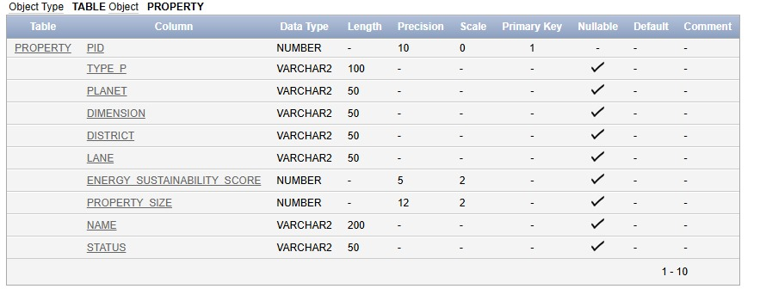

AFFILIATE
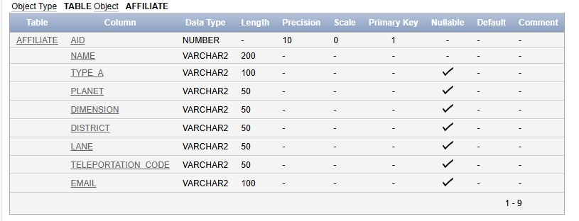

SERVICE

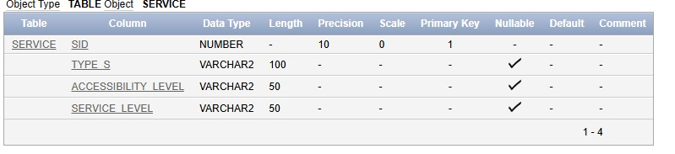

INSTITUTION

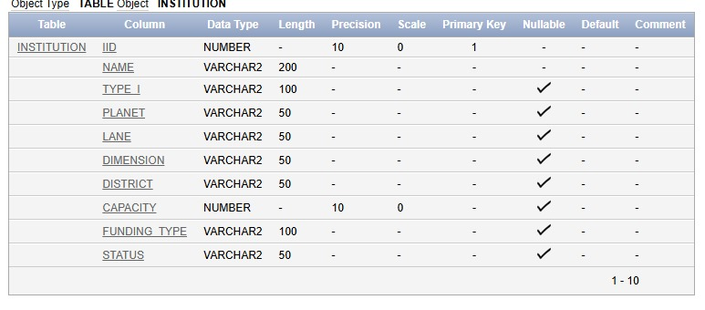

AVATAR

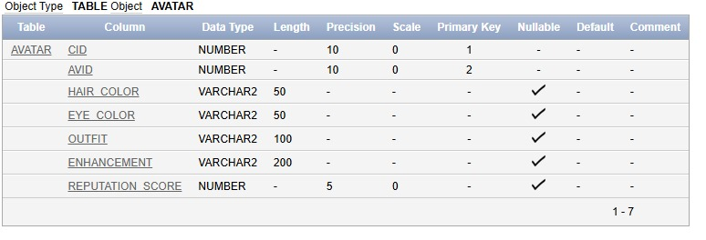

Owns_2

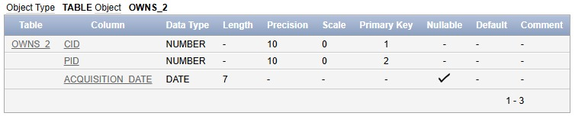

Supervises

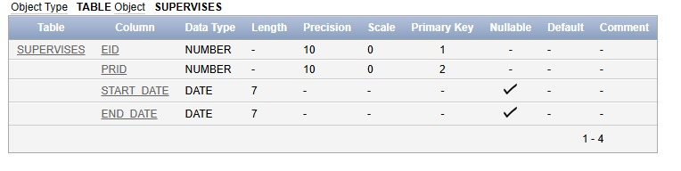

Oversees

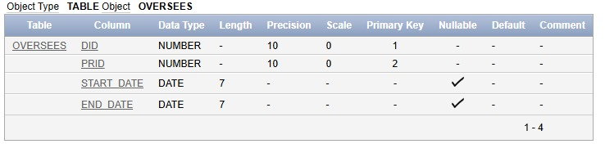

Issues

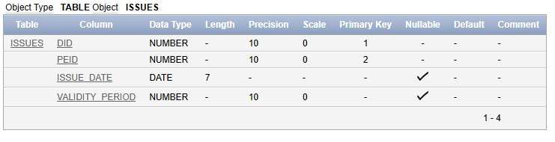
Employs

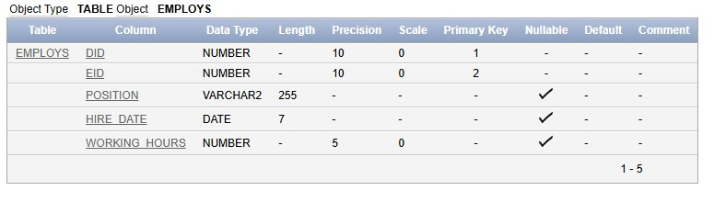
Provides

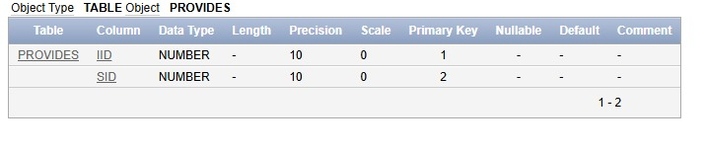
Has_2

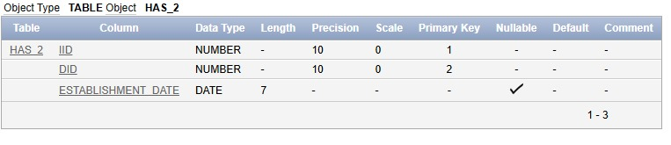
Owns_1

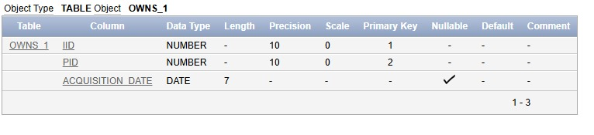
Uses_2
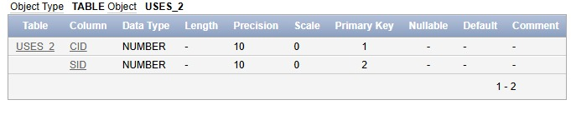
Is

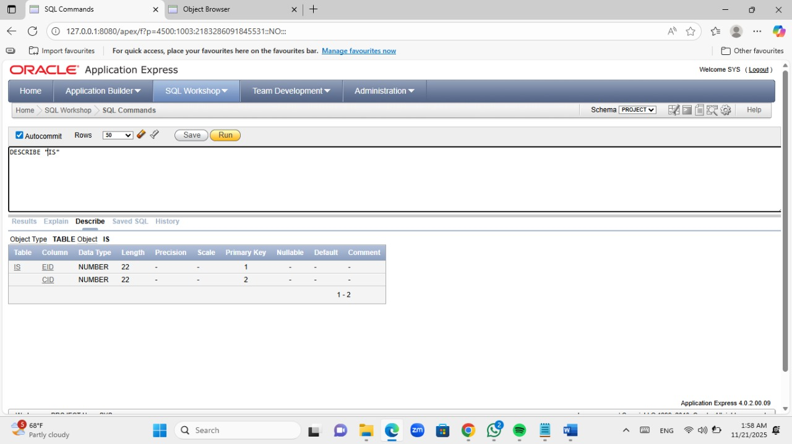

Partners_With

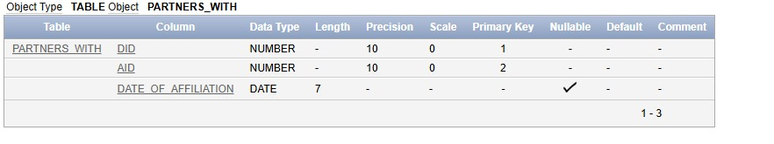
Education_Level

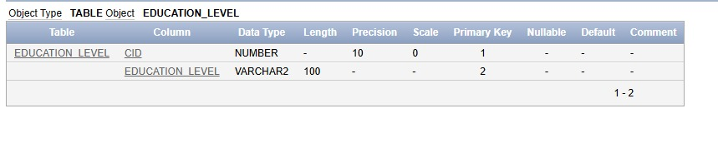
Dependents

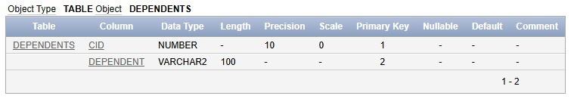

Holds

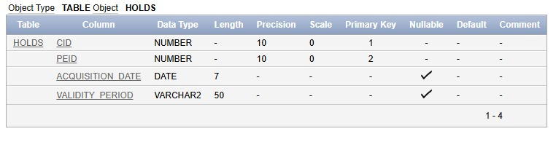
Supports
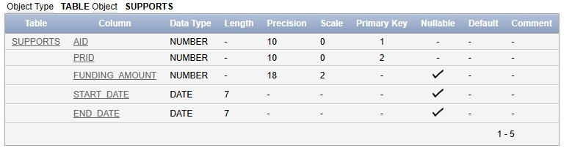
Employment_Status

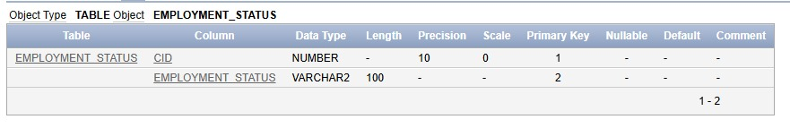

Qualifications

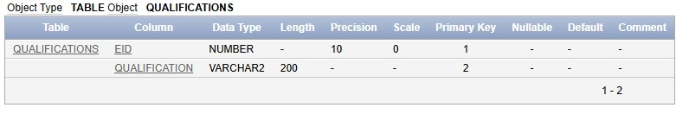
E_Phone
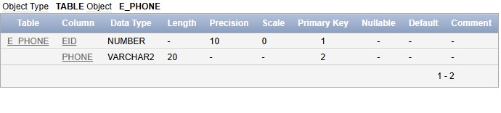E_Email

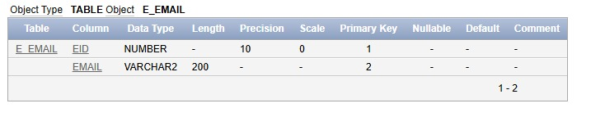
A_Phone

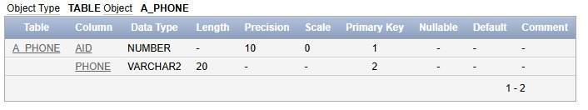

Virtual_Skills

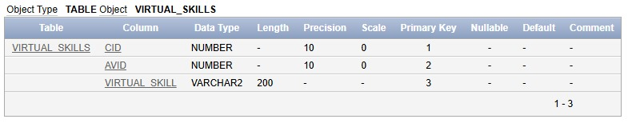

VIII. Data Insertion

CITIZEN

INSERT ALL
INTO CITIZEN VALUES (1001,'human','Aria','Tide',TO_DATE('2098-01-01','YYYY-MM-DD'),NULL,'Lena','Ravi','TER','SNG','Terra','Alpha','Central','Lane 1','Terran','NO','Lena Sol',96170111111,'Mother')
INTO CITIZEN VALUES (1002,'robot','Unit','RX-7',TO_DATE('2105-04-12','YYYY-MM-DD'),NULL,NULL,NULL,'MAR','SNG','Mars','Beta','North','Lane 7','Mechanian','NO','Support Hub',96170222222,'Service node')
INTO CITIZEN VALUES (1003,'human','Noor','Sky',TO_DATE('2092-09-20','YYYY-MM-DD'),NULL,'Aya','Jax','VEN','MAR','Venus','Gamma','Cloud','Lane 3','Terran','NO','Aya Nova',96170333333,'Mother')
INTO CITIZEN VALUES (1004,'human','Zed','Flux',TO_DATE('2085-11-11','YYYY-MM-DD'),NULL,'Mira','Omar','TER','SNG','Terra','Alpha','OldTown','Lane 2','Terran','YES','Omar Ray',96170444444,'Father')
INTO CITIZEN VALUES (1005,'robot','Core','X1',TO_DATE('2100-02-02','YYYY-MM-DD'),NULL,NULL,NULL,'JUP','SNG','Jupiter','Epsilon','Ring','Lane 5','Mechanian','NO','Control Hub',96170555555,'Supervisor')
INTO CITIZEN VALUES (1006,'human','Lina','Star',TO_DATE('2095-05-05','YYYY-MM-DD'),NULL,'Zara','Leo','TER','MAR','Terra','Alpha','Central','Lane 8','Polymorph','NO','Zara Quinn',96170666666,'Mother')
INTO CITIZEN VALUES (1007,'human','Yas','Ray',TO_DATE('2091-07-07','YYYY-MM-DD'),NULL,'Mira','Ravi','SAT','SNG','Saturn','Zeta','Outpost','Lane 11','Terran','NO','Mira Zen',96170777777,'Mother')
INTO CITIZEN VALUES (1008,'human','Odin','Pier',TO_DATE('2089-03-03','YYYY-MM-DD'),NULL,'Lena','Jax','TER','DIV','Terra','Alpha','Harbor','Lane 9','Terran','NO','Jax Orion',96170888888,'Father')
INTO CITIZEN VALUES (1009,'robot','Node','Q3',TO_DATE('2102-08-18','YYYY-MM-DD'),NULL,NULL,NULL,'SAT','SNG','Saturn','Zeta','Outpost','Lane 10','Mechanian','NO','Main Node',96170999999,'Controller')
INTO CITIZEN VALUES (1010,'human','Sara','Light',TO_DATE('2096-12-24','YYYY-MM-DD'),NULL,'Aya','Leo','TER','SNG','Terra','Alpha','Central','Lane 4','Polymorph','NO','Aya Nova',96171010101,'Mother')
SELECT * FROM dual;
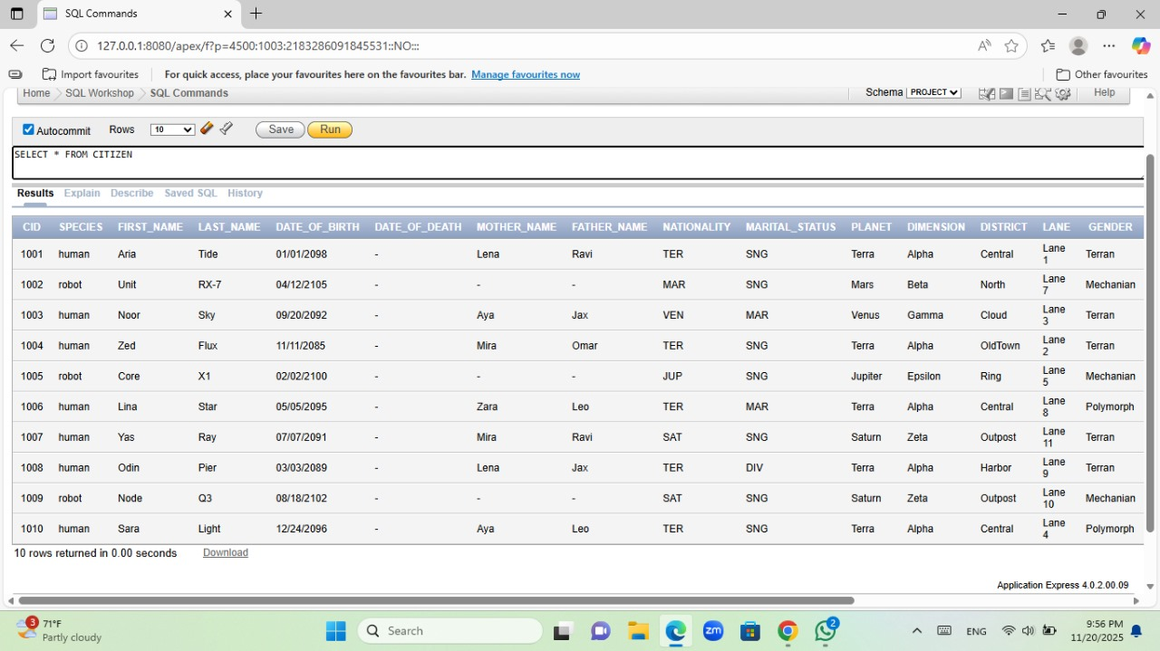

EMPLOYEE

INSERT ALL
INTO EMPLOYEE VALUES (1,'Lena','Sol',TO_DATE('2085-03-12','YYYY-MM-DD'),'Female','Terra','Alpha','Central','Lane 1','human',75000)
INTO EMPLOYEE VALUES (2,'Ravi','Khan',TO_DATE('2080-07-01','YYYY-MM-DD'),'Male','Mars','Beta','North','Lane 7','human',82000.50)
INTO EMPLOYEE VALUES (3,'Aya','Nova',TO_DATE('2090-11-22','YYYY-MM-DD'),'Female','Venus','Gamma','Cloud','Lane 3','hybrid',91000)
INTO EMPLOYEE VALUES (4,'Jax','Orion',TO_DATE('2075-01-05','YYYY-MM-DD'),'Other','Terra','Alpha','Harbor','Lane 9','robot',65000)
INTO EMPLOYEE VALUES (5,'Mira','Zen',TO_DATE('2088-05-18','YYYY-MM-DD'),'Female','Mars','Delta','Crater','Lane 4','human',70000)
INTO EMPLOYEE VALUES (6,'Omar','Ray',TO_DATE('2082-09-30','YYYY-MM-DD'),'Male','Terra','Alpha','OldTown','Lane 2','human',60000)
INTO EMPLOYEE VALUES (7,'Nova','Lux',TO_DATE('2093-02-14','YYYY-MM-DD'),'Female','Jupiter','Epsilon','Ring','Lane 5','robot',99000)
INTO EMPLOYEE VALUES (8,'Kai','Rho',TO_DATE('2084-12-01','YYYY-MM-DD'),'Male','Saturn','Zeta','Outpost','Lane 11','human',73000)
INTO EMPLOYEE VALUES (9,'Zara','Quinn',TO_DATE('2087-06-09','YYYY-MM-DD'),'Female','Terra','Alpha','Central','Lane 8','hybrid',88000)
INTO EMPLOYEE VALUES (10,'Leo','Storm',TO_DATE('2078-10-19','YYYY-MM-DD'),'Male','Mars','Beta','South','Lane 6','human',79000)
SELECT * FROM dual;

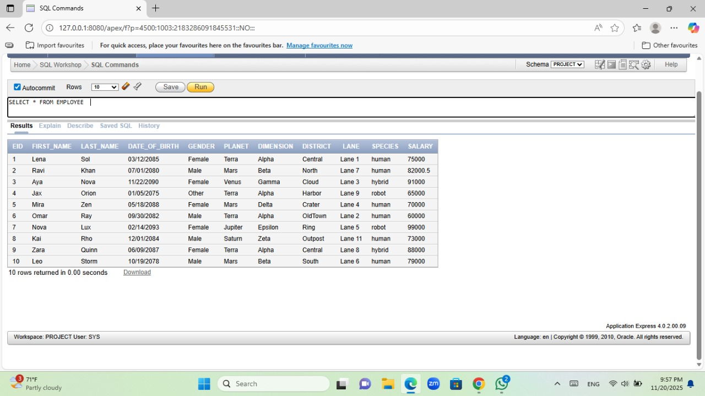

AVATAR

INSERT ALL
INTO AVATAR VALUES (1001,1,'Black','Brown','Explorer','Jetpack',85)
INTO AVATAR VALUES (1002,2,'Silver','Blue','Armor','Laser Sight',90)
INTO AVATAR VALUES (1003,3,'Brown','Green','Robe','Mind Link',78)
INTO AVATAR VALUES (1004,4,'Blonde','Hazel','Pilot','Neural Chip',82)
INTO AVATAR VALUES (1005,5,'Chrome','Red','TechSuit','Overclock',95)
INTO AVATAR VALUES (1006,6,'Red','Blue','Medic','Heal Field',88)
INTO AVATAR VALUES (1007,7,'Black','Gray','Scout','Camo Mesh',80)
INTO AVATAR VALUES (1008,8,'White','Amber','Captain','Shield Dome',92)
INTO AVATAR VALUES (1009,9,'Steel','Cyan','Drone','Quantum Link',89)
INTO AVATAR VALUES (1010,10,'Brown','Brown','Engineer','Tool Swarm',84)
SELECT * FROM dual;

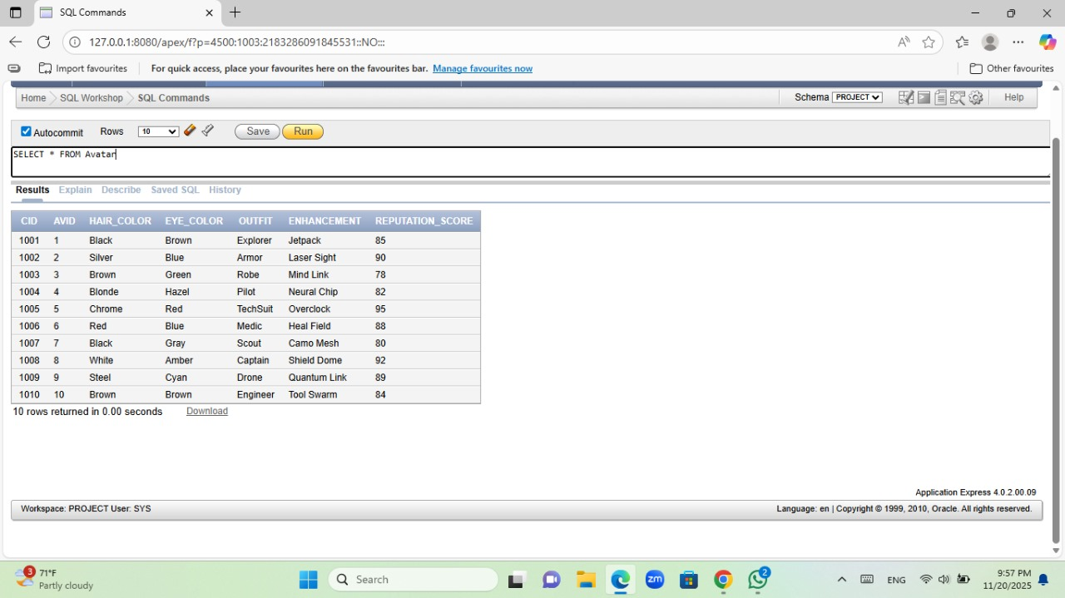

DEPARTMENT

INSERT ALL
INTO DEPARTMENT VALUES (201,'Central Ops','Coordination',1,'Terra','Alpha','Central','Lane 1','Local','ops@hub','1001','TP-TER-01')
INTO DEPARTMENT VALUES (202,'Mars Link','Logistics',2,'Mars','Beta','North','Lane 7','Interplanetary','mars@hub','1002','TP-MAR-02')
INTO DEPARTMENT VALUES (203,'Venus Cloud','Research',3,'Venus','Gamma','Cloud','Lane 3','Virtual','venus@hub','1003','TP-VEN-03')
INTO DEPARTMENT VALUES (204,'Harbor Gate','Security',4,'Terra','Alpha','Harbor','Lane 9','Local','gate@hub','1004','TP-TER-04')
INTO DEPARTMENT VALUES (205,'Energy Mars','Energy Mgmt',5,'Mars','Delta','Crater','Lane 4','Interplanetary','energy@hub','1005','TP-MAR-05')
INTO DEPARTMENT VALUES (206,'Saturn Out','Expansion',8,'Saturn','Zeta','Outpost','Lane 11','Interplanetary','saturn@hub','1006','TP-SAT-06')
INTO DEPARTMENT VALUES (207,'Jupiter Ring','Mining',7,'Jupiter','Epsilon','Ring','Lane 5','Interplanetary','ring@hub','1007','TP-JUP-07')
INTO DEPARTMENT VALUES (208,'OldTown Dev','Restoration',6,'Terra','Alpha','OldTown','Lane 2','Local','old@hub','1008','TP-TER-08')
INTO DEPARTMENT VALUES (209,'Central Lab','Innovation',9,'Terra','Alpha','Central','Lane 8','Virtual','lab@hub','1009','TP-TER-09')
INTO DEPARTMENT VALUES (210,'Transit Hub','Transport',10,'Mars','Beta','South','Lane 6','Interplanetary','transit@hub','1010','TP-MAR-10')
SELECT * FROM dual;

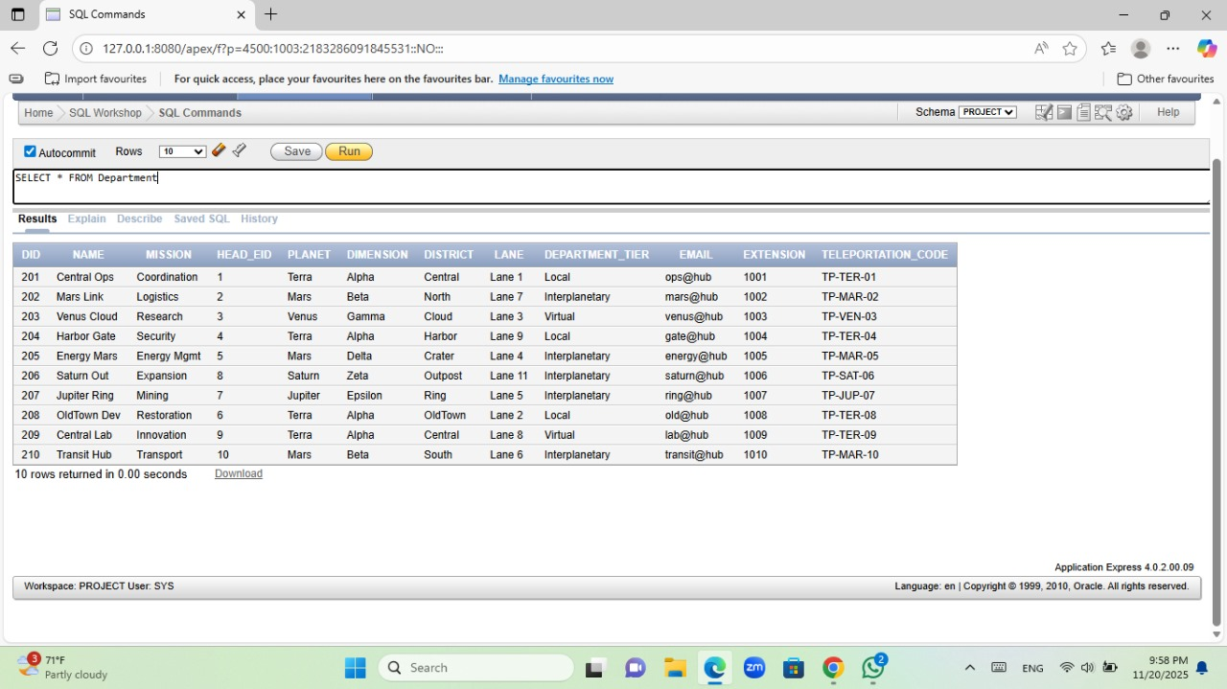

PERMIT

INSERT ALL
INTO PERMIT VALUES (401,'Dock Pass',TO_DATE('2120-01-10','YYYY-MM-DD'),365,TO_DATE('2121-01-10','YYYY-MM-DD'),204,'Citizen')
INTO PERMIT VALUES (402,'Mars Travel',TO_DATE('2120-02-15','YYYY-MM-DD'),730,TO_DATE('2122-02-15','YYYY-MM-DD'),202,'Citizen')
INTO PERMIT VALUES (403,'Research Lab',TO_DATE('2120-03-01','YYYY-MM-DD'),365,TO_DATE('2121-03-01','YYYY-MM-DD'),203,'Citizen')
INTO PERMIT VALUES (404,'Mining Access',TO_DATE('2120-03-20','YYYY-MM-DD'),365,TO_DATE('2121-03-20','YYYY-MM-DD'),207,'Citizen')
INTO PERMIT VALUES (405,'Transit Pass',TO_DATE('2120-04-05','YYYY-MM-DD'),180,TO_DATE('2120-10-02','YYYY-MM-DD'),210,'Visitor')
INTO PERMIT VALUES (406,'OldTown Entry',TO_DATE('2120-05-01','YYYY-MM-DD'),365,TO_DATE('2121-05-01','YYYY-MM-DD'),208,'Citizen')
INTO PERMIT VALUES (407,'Energy Zone',TO_DATE('2120-06-10','YYYY-MM-DD'),365,TO_DATE('2121-06-10','YYYY-MM-DD'),205,'Citizen')
INTO PERMIT VALUES (408,'Cloud Access',TO_DATE('2120-07-07','YYYY-MM-DD'),365,TO_DATE('2121-07-07','YYYY-MM-DD'),203,'Visitor')
INTO PERMIT VALUES (409,'Virtual Lab',TO_DATE('2120-08-08','YYYY-MM-DD'),365,TO_DATE('2121-08-08','YYYY-MM-DD'),209,'Citizen')
INTO PERMIT VALUES (410,'Central Ops',TO_DATE('2120-09-09','YYYY-MM-DD'),365,TO_DATE('2121-09-09','YYYY-MM-DD'),201,'Citizen')
SELECT * FROM dual;

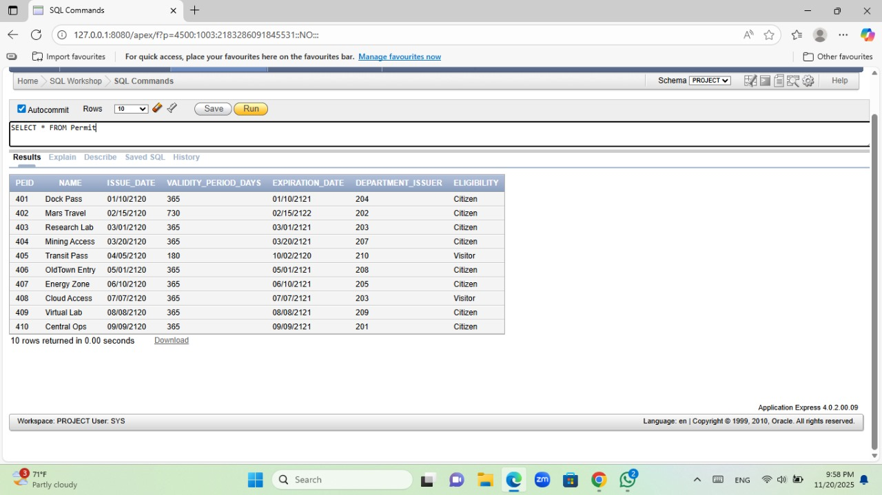

PROJECT

INSERT ALL
INTO PROJECT VALUES (501,'AquaNet',TO_DATE('2120-01-01','YYYY-MM-DD'),TO_DATE('2120-12-31','YYYY-MM-DD'),'Active','Water distribution upgrade.',201,1001,1)
INTO PROJECT VALUES (502,'MarsBridge',TO_DATE('2120-03-01','YYYY-MM-DD'),TO_DATE('2121-03-01','YYYY-MM-DD'),'Planned','Mars–Terra logistics bridge.',202,1002,2)
INTO PROJECT VALUES (503,'CloudLab',TO_DATE('2120-02-15','YYYY-MM-DD'),TO_DATE('2121-02-15','YYYY-MM-DD'),'Active','Venus cloud research.',203,1003,3)
INTO PROJECT VALUES (504,'HarborShield',TO_DATE('2120-04-01','YYYY-MM-DD'),TO_DATE('2120-10-01','YYYY-MM-DD'),'Active','Harbor security upgrade.',204,1004,4)
INTO PROJECT VALUES (505,'EnergyLoop',TO_DATE('2120-05-05','YYYY-MM-DD'),TO_DATE('2121-05-05','YYYY-MM-DD'),'Active','Closed-loop energy system.',205,1005,5)
INTO PROJECT VALUES (506,'RingMine',TO_DATE('2120-06-06','YYYY-MM-DD'),TO_DATE('2122-06-06','YYYY-MM-DD'),'Planned','Jupiter ring mining.',207,1006,6)
INTO PROJECT VALUES (507,'OutpostGrow',TO_DATE('2120-07-07','YYYY-MM-DD'),TO_DATE('2121-07-07','YYYY-MM-DD'),'Active','Saturn outpost expansion.',206,1007,7)
INTO PROJECT VALUES (508,'OldRevive',TO_DATE('2120-08-08','YYYY-MM-DD'),TO_DATE('2121-08-08','YYYY-MM-DD'),'Planned','OldTown restoration.',208,1008,8)
INTO PROJECT VALUES (509,'LabQuantum',TO_DATE('2120-09-09','YYYY-MM-DD'),TO_DATE('2122-09-09','YYYY-MM-DD'),'Active','Quantum lab initiative.',209,1009,9)
INTO PROJECT VALUES (510,'TransitGrid',TO_DATE('2120-10-10','YYYY-MM-DD'),TO_DATE('2121-10-10','YYYY-MM-DD'),'Planned','Unified transit grid.',210,1010,10)
SELECT * FROM dual;

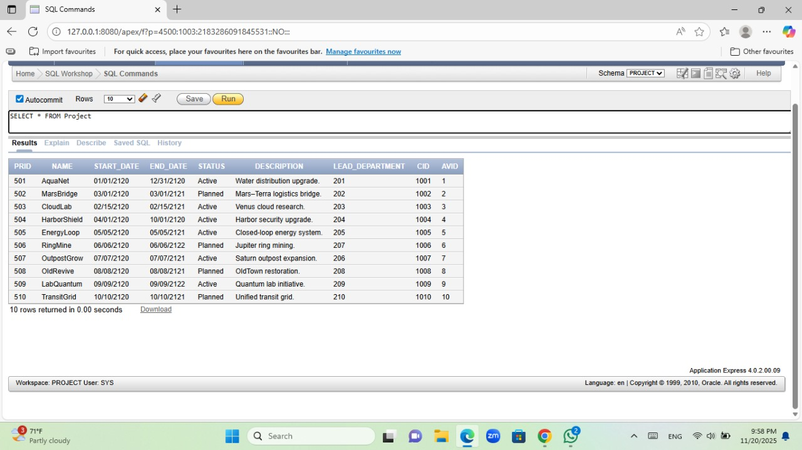

AFFILIATE

INSERT ALL
INTO AFFILIATE VALUES (801,'Terra Health Org','NGO','Terra','Alpha','Central','Lane 1','TP-THO-01','contact@tho')
INTO AFFILIATE VALUES (802,'Mars Mining Corp','Company','Mars','Beta','North','Lane 7','TP-MMC-02','info@mmc')
INTO AFFILIATE VALUES (803,'Venus Research Inst','Institute','Venus','Gamma','Cloud','Lane 3','TP-VRI-03','lab@vri')
INTO AFFILIATE VALUES (804,'Jupiter Resource Ltd','Company','Jupiter','Epsilon','Ring','Lane 5','TP-JRL-04','office@jrl')
INTO AFFILIATE VALUES (805,'Saturn Outpost Assoc','Association','Saturn','Zeta','Outpost','Lane 11','TP-SOA-05','team@soa')
INTO AFFILIATE VALUES (806,'Terra Education Fund','Foundation','Terra','Alpha','OldTown','Lane 2','TP-TEF-06','support@tef')
INTO AFFILIATE VALUES (807,'Central Transit Coop','Cooperative','Terra','Alpha','Central','Lane 8','TP-CTC-07','hub@ctc')
INTO AFFILIATE VALUES (808,'Crater Energy Union','Union','Mars','Delta','Crater','Lane 4','TP-CEU-08','union@ceu')
INTO AFFILIATE VALUES (809,'Harbor Trade Guild','Guild','Terra','Alpha','Harbor','Lane 9','TP-HTG-09','trade@htg')
INTO AFFILIATE VALUES (810,'Outpost Relief Net','NGO','Saturn','Zeta','Outpost','Lane 10','TP-ORN-10','relief@orn')
SELECT * FROM dual;

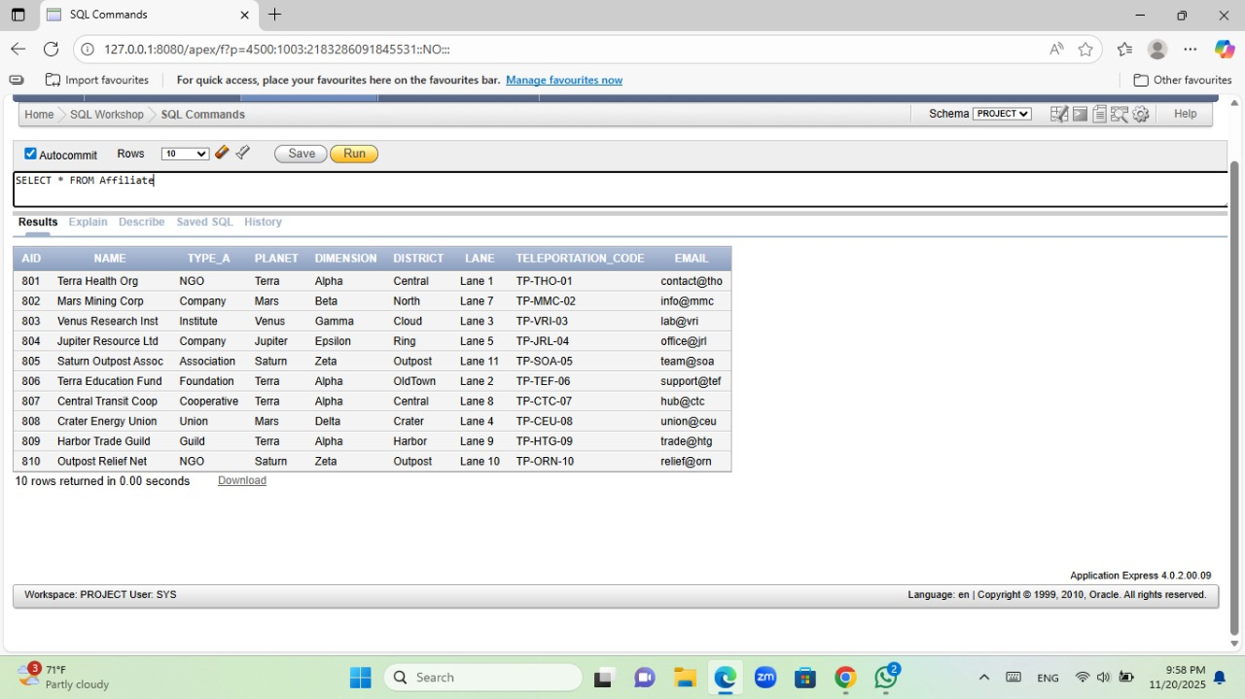

RESOURCE_MANAGEMENT

INSERT ALL
INTO RESOURCE_MANAGEMENT VALUES (301,'Water',5000,'Pure',TO_DATE('2120-01-01','YYYY-MM-DD'),'Active','Terra Depot',3650)
INTO RESOURCE_MANAGEMENT VALUES (302,'Food',2000,'Fresh',TO_DATE('2120-02-10','YYYY-MM-DD'),'Active','Mars Store',365)
INTO RESOURCE_MANAGEMENT VALUES (303,'Fuel',8000,'Stable',TO_DATE('2120-03-15','YYYY-MM-DD'),'Active','Ring Tank',1825)
INTO RESOURCE_MANAGEMENT VALUES (304,'Oxygen',6000,'Compressed',TO_DATE('2120-04-20','YYYY-MM-DD'),'Active','Cloud Vault',730)
INTO RESOURCE_MANAGEMENT VALUES (305,'Med Kits',500,'Packed',TO_DATE('2120-05-05','YYYY-MM-DD'),'Active','Central Med',365)
INTO RESOURCE_MANAGEMENT VALUES (306,'Spare Parts',1500,'Mixed',TO_DATE('2120-06-06','YYYY-MM-DD'),'Active','Harbor Bay',1825)
INTO RESOURCE_MANAGEMENT VALUES (307,'Solar Cells',1200,'New',TO_DATE('2120-07-07','YYYY-MM-DD'),'Active','Outpost Lab',3650)
INTO RESOURCE_MANAGEMENT VALUES (308,'Cables',3000,'Coiled',TO_DATE('2120-08-08','YYYY-MM-DD'),'Active','Transit Hub',3650)
INTO RESOURCE_MANAGEMENT VALUES (309,'Batteries',2500,'Charged',TO_DATE('2120-09-09','YYYY-MM-DD'),'Active','Energy Mars',1825)
INTO RESOURCE_MANAGEMENT VALUES (310,'Air Filters',1000,'Sealed',TO_DATE('2120-10-10','YYYY-MM-DD'),'Reserve','OldTown Dev',1095)
SELECT * FROM dual;

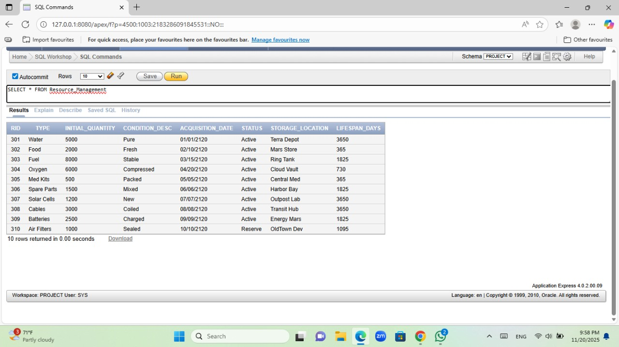

PROPERTY

INSERT ALL
INTO PROPERTY VALUES (601,'Habitat Dome','Terra','Alpha','Central','Lane 1',95.50,1200.75,'Central Habitat','Active')
INTO PROPERTY VALUES (602,'Research Lab','Venus','Gamma','Cloud','Lane 3',89.25,800,'Cloud Lab 1','Active')
INTO PROPERTY VALUES (603,'Mining Outpost','Jupiter','Epsilon','Ring','Lane 5',78,2000,'Ring Outpost','Active')
INTO PROPERTY VALUES (604,'Transit Hub','Mars','Beta','North','Lane 7',88,1500.5,'North Hub','Active')
INTO PROPERTY VALUES (605,'Energy Farm','Mars','Delta','Crater','Lane 4',99,3000,'Crater Solar','Active')
INTO PROPERTY VALUES (606,'Med Center','Terra','Alpha','OldTown','Lane 2',92.75,900.25,'OldTown Med','Active')
INTO PROPERTY VALUES (607,'Cargo Bay','Saturn','Zeta','Outpost','Lane 11',80,1800,'Outpost Cargo','Active')
INTO PROPERTY VALUES (608,'Dock Station','Terra','Alpha','Harbor','Lane 9',85,1600,'Harbor Dock','Active')
INTO PROPERTY VALUES (609,'Control Tower','Terra','Alpha','Central','Lane 8',90,1100,'Central Tower','Active')
INTO PROPERTY VALUES (610,'Training Hall','Mars','Beta','South','Lane 6',87.5,1300,'South Training','Active')
SELECT * FROM dual;

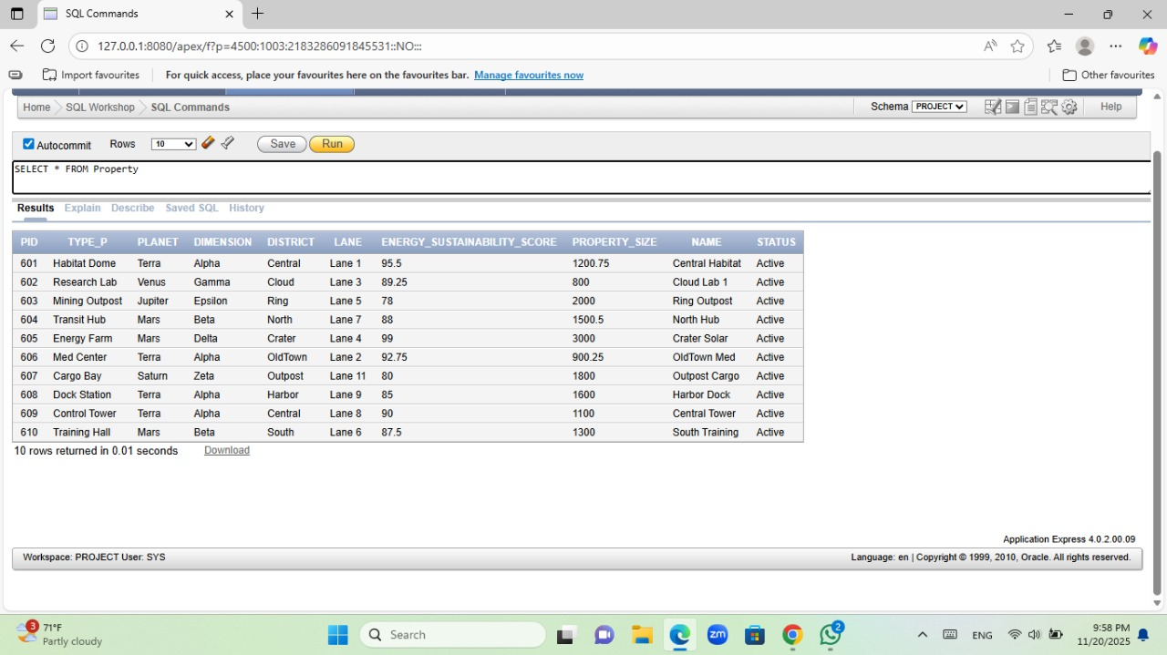

SERVICE

INSERT ALL
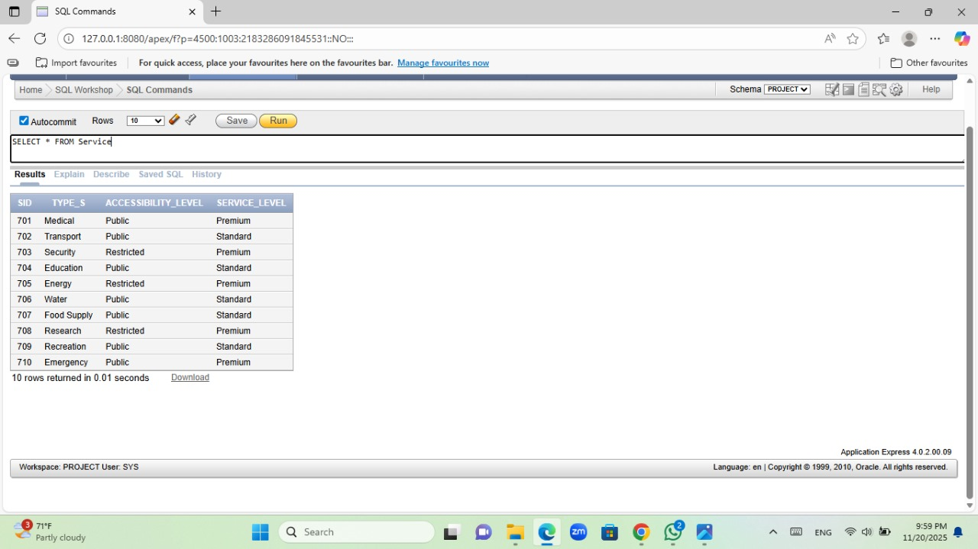
INTO SERVICE VALUES (701,'Medical','Public','Premium')
INTO SERVICE VALUES (702,'Transport','Public','Standard')
INTO SERVICE VALUES (703,'Security','Restricted','Premium')
INTO SERVICE VALUES (704,'Education','Public','Standard')
INTO SERVICE VALUES (705,'Energy','Restricted','Premium')
INTO SERVICE VALUES (706,'Water','Public','Standard')
INTO SERVICE VALUES (707,'Food Supply','Public','Standard')
INTO SERVICE VALUES (708,'Research','Restricted','Premium')
INTO SERVICE VALUES (709,'Recreation','Public','Standard')
INTO SERVICE VALUES (710,'Emergency','Public','Premium')
SELECT * FROM dual;
INSTITUTION

INSERT ALL
INTO INSTITUTION VALUES (901, 'Terra Central University', 'University', 'Terra', 'Alpha', 'Central', 'Lane 1', '15000', 'Public', 'Active')
INTO INSTITUTION VALUES (902, 'Mars Technical Institute', 'Institute', 'Mars', 'Beta', 'North', 'Lane 7', '5000', 'Public-Private', 'Active')
INTO INSTITUTION VALUES (903, 'Venus Cloud Research Academy', 'Research Center', 'Venus', 'Gamma', 'Cloud', 'Lane 3', '2000', 'Private', 'Active')
INTO INSTITUTION VALUES (904, 'Jupiter Ring Mining School', 'Training Center', 'Jupiter', 'Epsilon', 'Ring', 'Lane 5', '1200', 'Corporate', 'Active')
INTO INSTITUTION VALUES (905, 'Saturn Outpost Academy', 'Academy', 'Saturn', 'Zeta', 'Outpost', 'Lane 11', '3000', 'Public', 'Active')
INTO INSTITUTION VALUES (906, 'OldTown Restoration College', 'College', 'Terra', 'Alpha', 'OldTown', 'Lane 2', '2500', 'Public-Private', 'Active')
INTO INSTITUTION VALUES (907, 'Central Medical Institute', 'Medical School', 'Terra', 'Alpha', 'Central', 'Lane 8', '4000', 'Public', 'Active')
INTO INSTITUTION VALUES (908, 'Crater Energy Training Center', 'Training Center', 'Mars', 'Delta', 'Crater', 'Lane 4', '1800', 'Corporate', 'Active')
INTO INSTITUTION VALUES (909, 'Harbor Navigation School', 'Maritime School', 'Terra', 'Alpha', 'Harbor', 'Lane 9', '1000', 'Private', 'Active')
INTO INSTITUTION VALUES (910, 'Outpost Emergency Academy', 'Emergency School','Saturn', 'Zeta', 'Outpost', 'Lane 10', '2200', 'Public', 'Active')
SELECT * FROM dual;

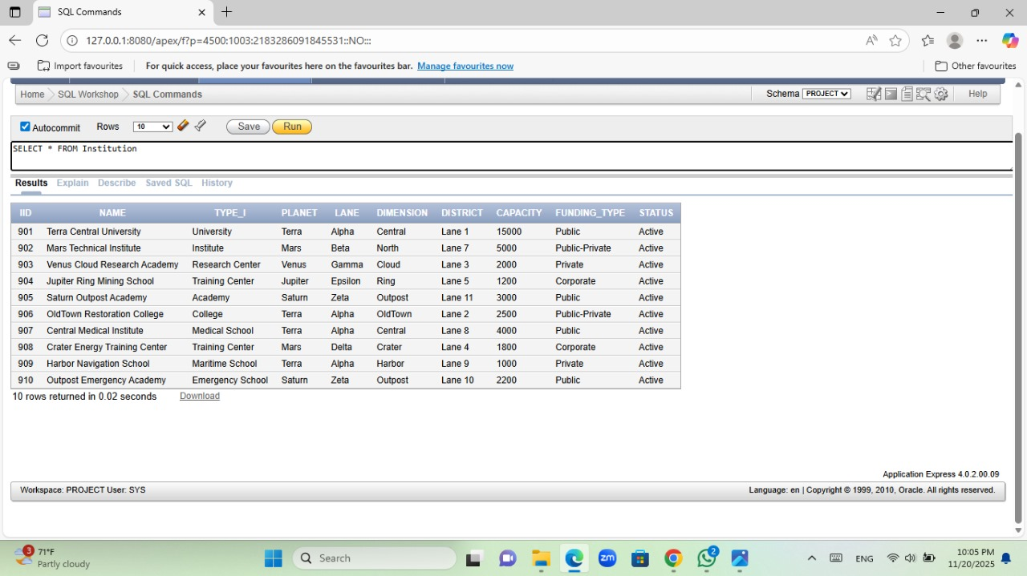

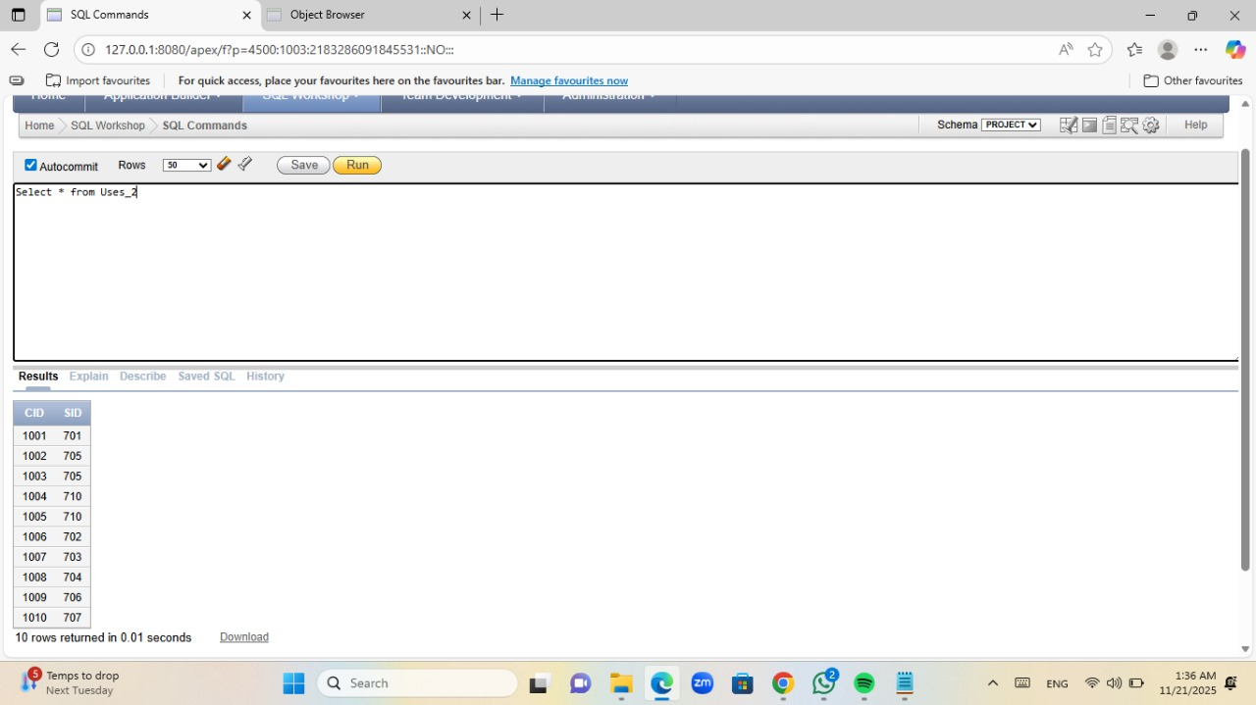
USES_2
INSERT INTO USES_2 VALUES (1,1);
INSERT INTO USES_2 VALUES (1,3);
INSERT INTO USES_2 VALUES (2,3);
INSERT INTO USES_2 VALUES (2,2);
INSERT INTO USES_2 VALUES (3,1);
INSERT INTO USES_2 VALUES (3,4);
INSERT INTO USES_2 VALUES (4,2);
INSERT INTO USES_2 VALUES (5,4);
INSERT INTO USES_2 VALUES (6,5);
INSERT INTO USES_2 VALUES (7,1);
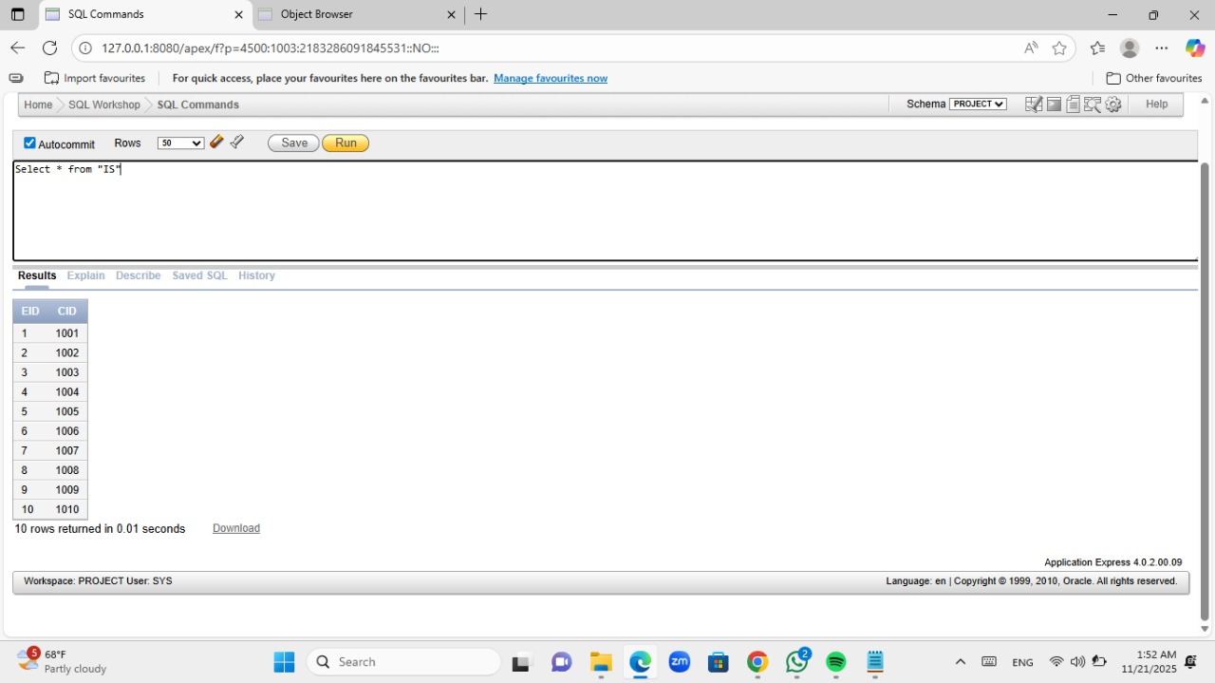
IS
INSERT ALL
INTO IS VALUES (1, 1001)
INTO IS VALUES (2, 1002)
INTO IS VALUES (3, 1003)
INTO IS VALUES (4, 1004)
INTO IS VALUES (5, 1005)
INTO IS VALUES (6, 1006)
INTO IS VALUES (7, 1007)
INTO IS VALUES (8, 1008)
INTO IS VALUES (9, 1009)
INTO IS VALUES (10, 1010)
SELECT * FROM dual;

CONSUMES
INSERT INTO CONSUMES VALUES (1,1,'Paid');
INSERT INTO CONSUMES VALUES (1,2,'Unpaid');
INSERT INTO CONSUMES VALUES (2,1,'Paid');
INSERT INTO CONSUMES VALUES (2,3,'Pending');
INSERT INTO CONSUMES VALUES (3,2,'Paid');
INSERT INTO CONSUMES VALUES (3,4,'Unpaid');
INSERT INTO CONSUMES VALUES (4,3,'Paid');
INSERT INTO CONSUMES VALUES (5,4,'Paid');
INSERT INTO CONSUMES VALUES (6,5,'Pending');
INSERT INTO CONSUMES VALUES (7,1,'Paid');

PARTNERS_WITH

INSERT INTO PARTNERS_WITH VALUES (1,1,DATE '2025-01-17');
INSERT INTO PARTNERS_WITH VALUES (1,2,DATE '2026-07-03');
INSERT INTO PARTNERS_WITH VALUES (2,1,DATE '2023-11-22');
INSERT INTO PARTNERS_WITH VALUES (2,3,DATE '2028-04-09');
INSERT INTO PARTNERS_WITH VALUES (3,2,DATE '2027-06-30');
INSERT INTO PARTNERS_WITH VALUES (3,4,DATE '2024-12-14');
INSERT INTO PARTNERS_WITH VALUES (1,3,DATE '2029-03-25');
INSERT INTO PARTNERS_WITH VALUES (2,4,DATE '2025-09-08');
INSERT INTO PARTNERS_WITH VALUES (3,1,DATE '2030-05-19');
INSERT INTO PARTNERS_WITH VALUES (1,4,DATE '2026-10-11');

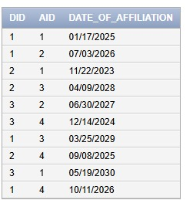

HOLDS
INSERT INTO HOLDS VALUES (1,1,DATE '2025-02-05','1 year');
INSERT INTO HOLDS VALUES (1,2,DATE '2027-08-18','2 years');
INSERT INTO HOLDS VALUES (2,1,DATE '2026-03-23','1 year');
INSERT INTO HOLDS VALUES (2,3,DATE '2028-11-12','3 years');
INSERT INTO HOLDS VALUES (3,2,DATE '2024-05-07','1 year');
INSERT INTO HOLDS VALUES (4,4,DATE '2029-09-29','2 years');
INSERT INTO HOLDS VALUES (5,5,DATE '2025-12-14','1 year');
INSERT INTO HOLDS VALUES (6,3,DATE '2030-01-01','3 years');
INSERT INTO HOLDS VALUES (7,1,DATE '2026-07-21','1 year');
INSERT INTO HOLDS VALUES (7,4,DATE '2027-04-03','2 years');

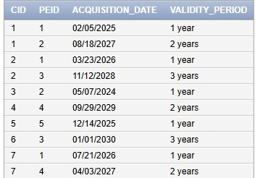

SUPPORTS
INSERT INTO SUPPORTS VALUES (1,1,50000,DATE '2025-01-10',DATE '2025-06-15');
INSERT INTO SUPPORTS VALUES (1,2,75000,DATE '2026-03-23',DATE '2026-09-30');
INSERT INTO SUPPORTS VALUES (2,1,60000,DATE '2024-08-05',DATE '2025-02-12');
INSERT INTO SUPPORTS VALUES (2,3,45000,DATE '2027-11-17',DATE '2028-05-22');
INSERT INTO SUPPORTS VALUES (3,2,80000,DATE '2029-06-30',DATE '2029-12-07');
INSERT INTO SUPPORTS VALUES (3,4,55000,DATE '2025-02-12',DATE '2025-08-20');
INSERT INTO SUPPORTS VALUES (4,5,70000,DATE '2026-09-25',DATE '2027-03-01');
INSERT INTO SUPPORTS VALUES (1,3,65000,DATE '2028-04-14',DATE '2028-10-21');
INSERT INTO SUPPORTS VALUES (2,4,72000,DATE '2025-07-08',DATE '2026-01-15');
INSERT INTO SUPPORTS VALUES (3,5,50000,DATE '2027-12-19',DATE '2028-06-27');

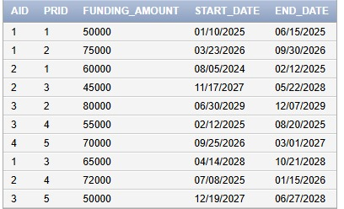

SUPPLIES
INSERT INTO SUPPLIES VALUES (1,3,DATE '2024-01-05');
INSERT INTO SUPPLIES VALUES (1,7,DATE '2024-02-12');
INSERT INTO SUPPLIES VALUES (2,1,DATE '2024-03-03');
INSERT INTO SUPPLIES VALUES (2,8,DATE '2024-03-21');
INSERT INTO SUPPLIES VALUES (3,4,DATE '2024-04-10');
INSERT INTO SUPPLIES VALUES (4,2,DATE '2024-04-18');
INSERT INTO SUPPLIES VALUES (5,9,DATE '2024-05-05');
INSERT INTO SUPPLIES VALUES (6,6,DATE '2024-05-22');
INSERT INTO SUPPLIES VALUES (7,10,DATE '2024-06-01');
INSERT INTO SUPPLIES VALUES (8,5,DATE '2024-06-17');

OWNS_2
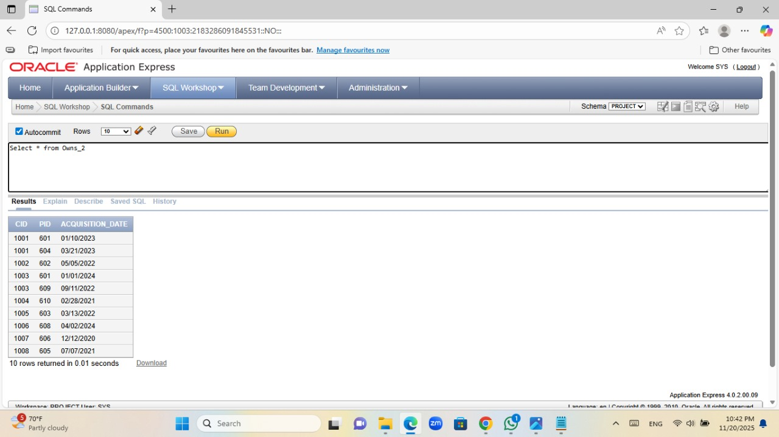
INSERT ALL
INTO OWNS_2 VALUES (1001, 701)
INTO OWNS_2 VALUES (1002, 702)
INTO OWNS_2 VALUES (1003, 703)
INTO OWNS_2 VALUES (1004, 704)
INTO OWNS_2 VALUES (1005, 705)
INTO OWNS_2 VALUES (1006, 706)
INTO OWNS_2 VALUES (1007, 707)
INTO OWNS_2 VALUES (1008, 708)
INTO OWNS_2 VALUES (1009, 709)
INTO OWNS_2 VALUES (1010, 710)
SELECT * FROM dual;

SUPERVISES

INSERT INTO SUPERVISES VALUES (1,6,DATE '2023-01-01',NULL);
INSERT INTO SUPERVISES VALUES (1,8,DATE '2023-03-10',NULL);
INSERT INTO SUPERVISES VALUES (2,1,DATE '2022-01-15',DATE '2022-07-01');
INSERT INTO SUPERVISES VALUES (3,3,DATE '2024-02-02',NULL);
INSERT INTO SUPERVISES VALUES (3,9,DATE '2024-03-03',NULL);
INSERT INTO SUPERVISES VALUES (4,2,DATE '2023-06-06',DATE '2023-12-12');
INSERT INTO SUPERVISES VALUES (5,7,DATE '2024-01-10',NULL);
INSERT INTO SUPERVISES VALUES (6,10,DATE '2024-04-04',NULL);
INSERT INTO SUPERVISES VALUES (7,4,DATE '2023-09-09',NULL);
INSERT INTO SUPERVISES VALUES (8,5,DATE '2023-11-11',DATE '2024-01-01');

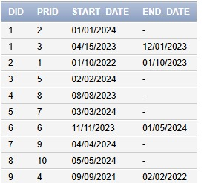

MANAGES
INSERT INTO MANAGES VALUES (1,1,'automated',DATE '2024-01-01');
INSERT INTO MANAGES VALUES (1,5,'manual',DATE '2024-01-23');
INSERT INTO MANAGES VALUES (2,7,'AI-Driven',DATE '2024-02-14');
INSERT INTO MANAGES VALUES (3,3,'manual',DATE '2024-03-01');
INSERT INTO MANAGES VALUES (4,9,'automated',DATE '2024-03-19');
INSERT INTO MANAGES VALUES (5,2,'manual',DATE '2024-04-04');
INSERT INTO MANAGES VALUES (6,8,'AI-Driven',DATE '2024-05-05');
INSERT INTO MANAGES VALUES (7,6,'automated',DATE '2024-06-06');
INSERT INTO MANAGES VALUES (8,10,'manual',DATE '2024-06-22');
INSERT INTO MANAGES VALUES (9,4,'AI-Driven',DATE '2024-07-01');

OVERSEES
INSERT INTO OVERSEES VALUES (1,2,DATE '2024-01-01',NULL);
INSERT INTO OVERSEES VALUES (1,3,DATE '2023-04-15',DATE '2023-12-01');
INSERT INTO OVERSEES VALUES (2,1,DATE '2022-01-10',DATE '2023-01-10');
INSERT INTO OVERSEES VALUES (3,5,DATE '2024-02-02',NULL);
INSERT INTO OVERSEES VALUES (4,8,DATE '2023-08-08',NULL);
INSERT INTO OVERSEES VALUES (5,7,DATE '2024-03-03',NULL);
INSERT INTO OVERSEES VALUES (6,6,DATE '2023-11-11',DATE '2024-01-05');
INSERT INTO OVERSEES VALUES (7,9,DATE '2024-04-04',NULL);
INSERT INTO OVERSEES VALUES (8,10,DATE '2024-05-05',NULL);
INSERT INTO OVERSEES VALUES (9,4,DATE '2021-09-09',DATE '2022-02-02');



ISSUES
INSERT INTO ISSUES VALUES (1,1,DATE '2023-01-01',12);
INSERT INTO ISSUES VALUES (1,7,DATE '2023-02-14',6);
INSERT INTO ISSUES VALUES (2,3,DATE '2022-03-03',18);
INSERT INTO ISSUES VALUES (3,5,DATE '2024-01-10',24);
INSERT INTO ISSUES VALUES (4,9,DATE '2023-08-08',36);
INSERT INTO ISSUES VALUES (5,2,DATE '2023-04-01',12);
INSERT INTO ISSUES VALUES (6,4,DATE '2023-05-20',6);
INSERT INTO ISSUES VALUES (7,6,DATE '2024-02-02',18);
INSERT INTO ISSUES VALUES (8,10,DATE '2024-03-03',12);
INSERT INTO ISSUES VALUES (9,8,DATE '2024-05-05',6);

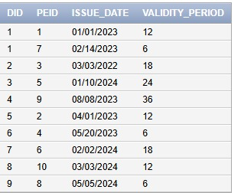

EMPLOYS
INSERT INTO EMPLOYS VALUES (1,4,'Analyst',DATE '2022-01-01',40);
INSERT INTO EMPLOYS VALUES (1,6,'Engineer',DATE '2023-03-03',42);
INSERT INTO EMPLOYS VALUES (2,1,'Manager',DATE '2021-07-07',38);
INSERT INTO EMPLOYS VALUES (3,8,'Technician',DATE '2022-09-09',40);
INSERT INTO EMPLOYS VALUES (4,2,'Auditor',DATE '2024-01-01',35);
INSERT INTO EMPLOYS VALUES (5,9,'Supervisor',DATE '2023-12-12',40);
INSERT INTO EMPLOYS VALUES (6,7,'Coordinator',DATE '2023-05-05',36);
INSERT INTO EMPLOYS VALUES (7,3,'Intern',DATE '2024-02-14',20);
INSERT INTO EMPLOYS VALUES (8,10,'Lead Engineer',DATE '2022-02-02',48);
INSERT INTO EMPLOYS VALUES (9,5,'Assistant',DATE '2024-04-04',30);

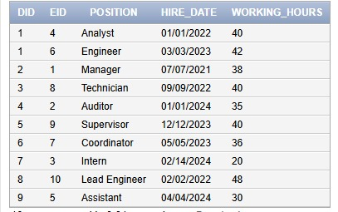

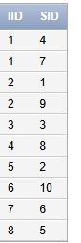
PROVIDES
INSERT INTO PROVIDES VALUES (1,4);
INSERT INTO PROVIDES VALUES (1,7);
INSERT INTO PROVIDES VALUES (2,1);
INSERT INTO PROVIDES VALUES (2,9);
INSERT INTO PROVIDES VALUES (3,3);
INSERT INTO PROVIDES VALUES (4,8);
INSERT INTO PROVIDES VALUES (5,2);
INSERT INTO PROVIDES VALUES (6,10);
INSERT INTO PROVIDES VALUES (7,6);
INSERT INTO PROVIDES VALUES (8,5);

USES_1
INSERT INTO USES_1 VALUES (1,8,200);
INSERT INTO USES_1 VALUES (1,3,350);
INSERT INTO USES_1 VALUES (2,5,180);
INSERT INTO USES_1 VALUES (3,1,260);
INSERT INTO USES_1 VALUES (4,7,300);
INSERT INTO USES_1 VALUES (5,2,410);
INSERT INTO USES_1 VALUES (6,10,500);
INSERT INTO USES_1 VALUES (7,6,270);
INSERT INTO USES_1 VALUES (8,9,320);
INSERT INTO USES_1 VALUES (9,4,290);

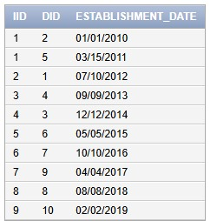
HAS_2
INSERT INTO HAS_2 VALUES (1,2,DATE '2010-01-01');
INSERT INTO HAS_2 VALUES (1,5,DATE '2011-03-15');
INSERT INTO HAS_2 VALUES (2,1,DATE '2012-07-10');
INSERT INTO HAS_2 VALUES (3,4,DATE '2013-09-09');
INSERT INTO HAS_2 VALUES (4,3,DATE '2014-12-12');
INSERT INTO HAS_2 VALUES (5,6,DATE '2015-05-05');
INSERT INTO HAS_2 VALUES (6,7,DATE '2016-10-10');
INSERT INTO HAS_2 VALUES (7,9,DATE '2017-04-04');
INSERT INTO HAS_2 VALUES (8,8,DATE '2018-08-08');
INSERT INTO HAS_2 VALUES (9,10,DATE '2019-02-02');

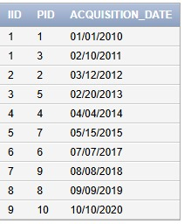
OWNS_1
INSERT INTO OWNS_1 VALUES (1,1,DATE '2010-01-01');
INSERT INTO OWNS_1 VALUES (1,3,DATE '2011-02-10');
INSERT INTO OWNS_1 VALUES (2,2,DATE '2012-03-12');
INSERT INTO OWNS_1 VALUES (3,5,DATE '2013-02-20');
INSERT INTO OWNS_1 VALUES (4,4,DATE '2014-04-04');
INSERT INTO OWNS_1 VALUES (5,7,DATE '2015-05-15');
INSERT INTO OWNS_1 VALUES (6,6,DATE '2017-07-07');
INSERT INTO OWNS_1 VALUES (7,9,DATE '2018-08-08');
INSERT INTO OWNS_1 VALUES (8,8,DATE '2019-09-09');
INSERT INTO OWNS_1 VALUES (9,10,DATE '2020-10-10');

EMPLOYMENT_STATUS
INSERT INTO EMPLOYMENT_STATUS VALUES (1,'Unemployed');
INSERT INTO EMPLOYMENT_STATUS VALUES (2,'Part-time Researcher');
INSERT INTO EMPLOYMENT_STATUS VALUES (2,'Full-time Engineer');
INSERT INTO EMPLOYMENT_STATUS VALUES (3,'Freelancer');
INSERT INTO EMPLOYMENT_STATUS VALUES (4,'Full-time Scientist');
INSERT INTO EMPLOYMENT_STATUS VALUES (5,'Part-time Teacher');
INSERT INTO EMPLOYMENT_STATUS VALUES (6,'Intern');
INSERT INTO EMPLOYMENT_STATUS VALUES (7,'Full-time Administrator');
INSERT INTO EMPLOYMENT_STATUS VALUES (8,'Contractor');
INSERT INTO EMPLOYMENT_STATUS VALUES (9,'Full-time Pilot');
INSERT INTO EMPLOYMENT_STATUS VALUES (10,'Research Assistant');

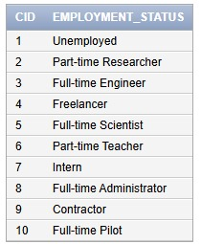

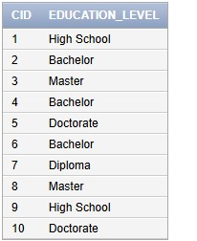
EDUCATION_LEVEL
INSERT INTO EDUCATION_LEVEL VALUES (1,'High School');
INSERT INTO EDUCATION_LEVEL VALUES (2,'Bachelor');
INSERT INTO EDUCATION_LEVEL VALUES (2,'Master');
INSERT INTO EDUCATION_LEVEL VALUES (3,'Bachelor');
INSERT INTO EDUCATION_LEVEL VALUES (4,'Doctorate');
INSERT INTO EDUCATION_LEVEL VALUES (5,'Bachelor');
INSERT INTO EDUCATION_LEVEL VALUES (6,'Diploma');
INSERT INTO EDUCATION_LEVEL VALUES (7,'Master');
INSERT INTO EDUCATION_LEVEL VALUES (8,'High School');
INSERT INTO EDUCATION_LEVEL VALUES (9,'Doctorate');
INSERT INTO EDUCATION_LEVEL VALUES (10,'Bachelor');

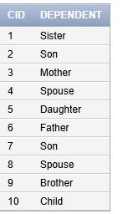
DEPENDENTS
INSERT INTO DEPENDENTS VALUES (1,'Sister');
INSERT INTO DEPENDENTS VALUES (1,'Son');
INSERT INTO DEPENDENTS VALUES (2,'Mother');
INSERT INTO DEPENDENTS VALUES (3,'Spouse');
INSERT INTO DEPENDENTS VALUES (3,'Daughter');
INSERT INTO DEPENDENTS VALUES (4,'Father');
INSERT INTO DEPENDENTS VALUES (5,'Son');
INSERT INTO DEPENDENTS VALUES (6,'Spouse');
INSERT INTO DEPENDENTS VALUES (7,'Brother');
INSERT INTO DEPENDENTS VALUES (10,'Child');

QUALIFICATIONS
INSERT INTO QUALIFICATIONS VALUES (1,'Cybernetics Engineering');
INSERT INTO QUALIFICATIONS VALUES (1,'AI Specialist');
INSERT INTO QUALIFICATIONS VALUES (2,'Quantum Physics');
INSERT INTO QUALIFICATIONS VALUES (3,'Terraforming Expert');
INSERT INTO QUALIFICATIONS VALUES (4,'Botany');
INSERT INTO QUALIFICATIONS VALUES (5,'Planetary Sciences');
INSERT INTO QUALIFICATIONS VALUES (6,'Astrophysics');
INSERT INTO QUALIFICATIONS VALUES (7,'Robotics');
INSERT INTO QUALIFICATIONS VALUES (8,'Interstellar Navigation');
INSERT INTO QUALIFICATIONS VALUES (9,'Resource Management');

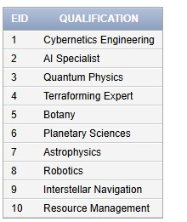

E_PHONE
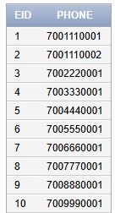
INSERT INTO E_PHONE VALUES (1,'7001110001');
INSERT INTO E_PHONE VALUES (1,'7001110002');
INSERT INTO E_PHONE VALUES (2,'7002220001');
INSERT INTO E_PHONE VALUES (3,'7003330001');
INSERT INTO E_PHONE VALUES (4,'7004440001');
INSERT INTO E_PHONE VALUES (5,'7005550001');
INSERT INTO E_PHONE VALUES (6,'7006660001');
INSERT INTO E_PHONE VALUES (7,'7007770001');
INSERT INTO E_PHONE VALUES (8,'7008880001');
INSERT INTO E_PHONE VALUES (9,'7009990001');
INSERT INTO E_PHONE VALUES (10,'7010000001');

E_EMAIL

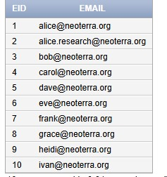
INSERT INTO E_EMAIL VALUES (1,'alice@neoterra.org');
INSERT INTO E_EMAIL VALUES (1,'alice.research@neoterra.org');
INSERT INTO E_EMAIL VALUES (2,'bob@neoterra.org');
INSERT INTO E_EMAIL VALUES (3,'carol@neoterra.org');
INSERT INTO E_EMAIL VALUES (4,'dave@neoterra.org');
INSERT INTO E_EMAIL VALUES (5,'eve@neoterra.org');
INSERT INTO E_EMAIL VALUES (6,'frank@neoterra.org');
INSERT INTO E_EMAIL VALUES (7,'grace@neoterra.org');
INSERT INTO E_EMAIL VALUES (8,'heidi@neoterra.org');
INSERT INTO E_EMAIL VALUES (9,'ivan@neoterra.org');
INSERT INTO E_EMAIL VALUES (10,'judy@neoterra.org');

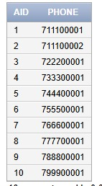
A_PHONE

INSERT INTO A_PHONE VALUES (1,'711100001');
INSERT INTO A_PHONE VALUES (1,'711100002');
INSERT INTO A_PHONE VALUES (2,'722200001');
INSERT INTO A_PHONE VALUES (3,'733300001');
INSERT INTO A_PHONE VALUES (4,'744400001');
INSERT INTO A_PHONE VALUES (5,'755500001');
INSERT INTO A_PHONE VALUES (6,'766600001');
INSERT INTO A_PHONE VALUES (7,'777700001');
INSERT INTO A_PHONE VALUES (8,'788800001');
INSERT INTO A_PHONE VALUES (9,'799900001');
INSERT INTO A_PHONE VALUES (10,'7100000001');

VIRTUAL_SKILLS
INSERT INTO VIRTUAL_SKILLS VALUES (1,1,'Hologram Manipulation');
INSERT INTO VIRTUAL_SKILLS VALUES (1,1,'Stealth Protocols');
INSERT INTO VIRTUAL_SKILLS VALUES (2,2,'Drone Piloting');
INSERT INTO VIRTUAL_SKILLS VALUES (3,1,'Virtual Engineering');
INSERT INTO VIRTUAL_SKILLS VALUES (4,1,'Digital Combat');
INSERT INTO VIRTUAL_SKILLS VALUES (5,1,'AI Simulation');
INSERT INTO VIRTUAL_SKILLS VALUES (6,1,'Terraforming Simulation');
INSERT INTO VIRTUAL_SKILLS VALUES (7,1,'Space Navigation');
INSERT INTO VIRTUAL_SKILLS VALUES (8,1,'Medical Simulation');
INSERT INTO VIRTUAL_SKILLS VALUES (9,1,'Robotics Control');
INSERT INTO VIRTUAL_SKILLS VALUES (10,1,'Cyber Defense');

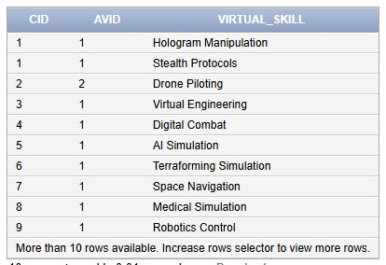

IX. Queries

Scenario 1:
The Human Resources AI scanned the employee database, searching for humans whose salaries fell below the average of their own species.
A quiet alert pulsed on the holo-screen, highlighting names drifting beneath the “fair compensation threshold.”
They weren’t under-working employees. They were simply lost in the shadows of a system that had overlooked them.
The algorithm drew connections, comparing each human’s earnings to the collective heartbeat of their workforce.
By the end of the scan, a list emerged, humans deserving recognition, balance, and a rightful share of equity in the city’s evolving economy.
SELECT e.EID, e.First_Name, e.Last_Name, e.Species, e.Salary
FROM EMPLOYEE e
JOIN (
SELECT Species, AVG(Salary) AS Avg_Salary
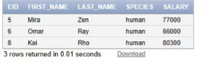
FROM EMPLOYEE
GROUP BY Species
) pos_avg
ON e.Species = pos_avg.Species
WHERE e.Species = 'human'
AND e.Salary < pos_avg.Avg_Salary;

Scenario 2:
This query scans through every department and pulls out the ones whose mission statements quietly contain the mark of AI. By lowering the text first, it catches any mention of artificial intelligence. The result is a filtered list of departments whose goals are shaped, influenced, or driven by AI-related ambitions. As a futuristic municipality, we need to be as immersed in ai and such a query gives an indication of where we are and how much we need to progress in terms of artificial intelligence
SELECT did, name, mission
FROM department
WHERE LOWER(mission) LIKE '%ai%';
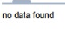
As we have no such occurrence, our municipality is in dire need of an AI revolution.

Scenario 3:
Due to a system malfunction in the Neoterra payroll module, several employee salaries were reset to outdated values. The board immediately contacted the DBA to correct the issue. To ensure fair compensation, the DBA issued the following queries to reapply the raise policy. He retrieved all employees and updated their salaries: 10% for all employees, and an additional 40% for those in the heads of departments in the Tech Division (because they deserve it).
He issued the queries that might help:
UPDATE EMPLOYEE
SET Salary = Salary * 1.10;
UPDATE EMPLOYEE e
SET Salary = Salary * 1.40
WHERE e.EID IN (
SELECT d.Head_EID
FROM DEPARTMENT d
WHERE d.Name = 'Central Ops'
AND d.Head_EID IS NOT NULL
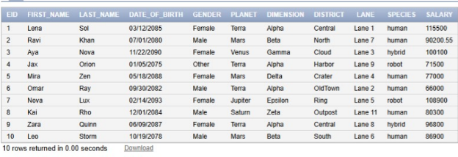
);

Scenario 4:
The system scans through all projects still stuck in the “Planned” stage, not yet brought to life.
But it doesn’t delete blindly: it checks whether each project is tied to an avatar that actually exists.
If the avatar is real and its identity matches the project’s records, the project is marked for removal.
It’s like clearing out blueprints that were never meant to be built, but still linked to real citizens.
In the end, the database cleans up forgotten plans, keeping only what truly has a future.
DELETE FROM PROJECT P
WHERE P.Status = 'Planned'
AND EXISTS (
SELECT 1
FROM AVATAR A
WHERE A.CID = P.CID
AND A.AVID = P.AVID
);
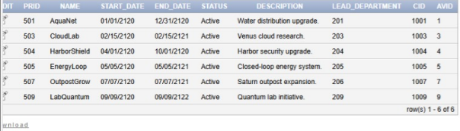

Scenario 5:
The city’s network pulsed with activity as the system filtered through every active project scattered across the multiverse grid.
Each project was traced back to its lead department, its coordinates anchored in planet, dimension, district, and lane.
From there, the system searched for affiliates sharing the exact same cosmic address, perfect geographical matches in a layered reality.
One by one, affiliates emerged: partners aligned not by chance, but by shared space and purpose.
Together they formed a living map of active collaborations, showing which worlds were working in harmony to keep the municipality thriving.
SELECT A.AID, A.Name, P.PRID, P.Status
FROM PROJECT P
JOIN DEPARTMENT D
ON P.Lead_Department = D.DID
JOIN AFFILIATE A
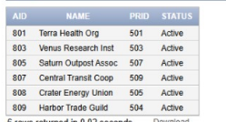
ON A.Planet = D.Planet
AND A.Dimension = D.Dimension
AND A.District = D.District
AND A.Lane = D.Lane
WHERE P.Status = 'Active';

Scenario 6:
This query pieces together the full profile of a citizen living on Planet Terra, pulling in their identity, property, avatar, and permit records.
It hunts specifically for citizens who own active properties, ensuring they're part of a functioning and sustainable district.
Their avatars are checked too, highlighting individuals with reputation scores below 90, hinting at trouble, risk, or rising tension.
Even their active permits are pulled in, showing whether they’re still allowed to operate, build, or move freely in their sector.
All together, it forms a layered snapshot of NeoTerra residents who look stable on paperbut whose digital reputations suggest deeper stories beneath the surface.

SELECT
C.CID,
C.First_Name || ' ' || C.Last_Name AS Full_Name,
C.Planet, C.Dimension, C.District,
P.PID AS Property_ID,
P.Status AS Property_Status,
P.Energy_Sustainability_Score,
A.AVID AS Avatar_ID,
A.Reputation_Score,
PE.PEID AS Active_Permit,
PE.Expiration_Date
FROM CITIZEN C
JOIN OWNS_2 ON C.CID = OWNS_2.CID
JOIN PROPERTY P ON OWNS_2.PID = P.PID
JOIN AVATAR A ON C.CID = A.CID
JOIN HOLDS H ON C.CID = H.CID
JOIN PERMIT PE ON H.PEID = PE.PEID
WHERE
C.Planet = 'Terra'
AND P.Status = 'Active'
AND A.Reputation_Score < 90;

Scenario 7:
The database combed through all resources, searching for those that were fading too quickly.
A benchmark was set: half of the average lifespan of every managed resource.
Anything that couldn’t even reach that halfway mark was flagged as critically short-lived.
These fragile entries stood out as warnings, items deteriorating far faster than the rest.
The query revealed the weakest links in the system, urging attention before they expired entirely.
SELECT R.RID, R.Type, R.Lifespan_Days
FROM RESOURCE_MANAGEMENT R
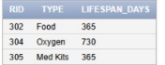
WHERE R.Lifespan_Days < (
SELECT AVG(R2.Lifespan_Days) * 0.5
FROM RESOURCE_MANAGEMENT R2
);

Scenario 8:
The system scans all citizens and looks for those who do own property, but only the right kind.
It filters out anyone tied to inactive properties, avoiding citizens with abandoned or shut-down estates.
Only those who own at least one property, and none of them inactive, make it through the filter.
It’s like identifying responsible owners whose holdings are still alive and thriving.
In the end, the query highlights citizens whose property portfolios remain fully active and trouble-free.
SELECT C.CID, C.First_Name, C.Last_Name
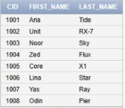
FROM CITIZEN C
WHERE C.CID NOT IN (
SELECT OWNS_2.CID
FROM OWNS_2
JOIN PROPERTY P ON OWNS_2.PID = P.PID
WHERE P.Status = 'Inactive'
)
AND C.CID IN (
SELECT OWNS_2.CID
FROM OWNS_2
);

Scenario 9:
The Department of Civic Compliance wants to identify highly active citizens who frequently apply for legal authorizations.
Some citizens seem to be “permit collectors”—holding multiple active permits at once.
The board wants to generate a list of:
Citizens who hold more than one permit
The count of permits each one has
This helps the department detect heavy service users or potential misuse.
SELECT
C.CID,
C.First_Name,
C.Last_Name,
COUNT(H.PEID) AS permit_count
FROM CITIZEN C

JOIN HOLDS H ON C.CID = H.CID
GROUP BY C.CID, C.First_Name, C.Last_Name
HAVING COUNT(H.PEID) > 1
ORDER BY permit_count DESC;

